BHP Facilitator Guide Virtual Live Day

This guide is exclusively for the use of Certified BHP Instructors to facilitate the Virtual Live Day training of the BHP Blended Learning Curriculum.
These activities and discussions are intended to reinforce learning and retention of the online BHP content and increase proficiency in the skills needed to be an effective BHP. Please review the Tips for Virtual Classroom Facilitation Guide.

Materials:
- BHP Virtual Live Day Training Documentation Form
- CPR/FA/BBP Verification Form
- Live Day Learning Journal
- BHP Virtual Live Day PowerPoint w/ Instructors’ notes and hyperlinks

This Facilitator Guide is designed for use in Adobe Connect having both a Certified BHP Instructor as the Facilitator and a second person assisting behind the scenes as the Producer. It may be modified for other virtual platforms such as Zoom, Google Hangouts, etc. Some platforms such as Adobe require you to build your classroom prior to your Live Day class – upload the PowerPoint slides and create the layouts, upload documents such as the Live Day learning journal in the file share pod, and create polls. Please note: to create separate layouts for each section, you must separate the PowerPoint presentation and upload it in separate share pods by section/module, rather than uploading the entire presentation.
Column 1 provides the image of the  BHP Live Day PowerPoint slide. | Column 2 provides you with your script and instructor’s notes for activities, discussions, and student engagement. | Column 3 provides instructions for handling the technology.
Slide/Page | Facilitator | Producer
Layout:  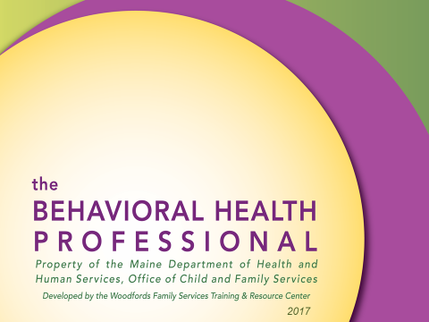  Slide #1 | SAY:  We have provided you with a script. Feel free to paraphrase using your own words.  Anything highlighted in green is an opportunity to elicit participation from the learners.  DO: | DO:
Slide/Page | Facilitator | Producer
Layout: Welcome  Slide #1 | DO:  Greet learners as they enter the room.  Thank them for being early/on time.  Encourage them to participate in the poll.  SAY: Welcome to the Virtual Classroom!  We are looking forward to our time with you over the next two days.  While we are waiting for everyone to join, please take a moment to participate in the polls.  In addition, the Learning journal that we will be using today and tomorrow, as well as the BHP Student Manual in its entirety are available for download in the file share pod.  If you haven’t done so already, please download those now, particularly the learning journal.  I’ve typed our cell phone numbers into Chat. I encourage you to jot those down. If you are bumped out of the classroom or need assistance, feel free to call or text us. Our Producer: _______________ is the best person to contact for assistance with issues related to technology.  DO:  When it is time to begin class, advance to the next layout: How to Communicate in Virtual Classroom.  SAY:  Thank you everyone for being prepared and arriving on time! And for participating on our poll.  We are looking forward to learning more from each of you and will have you introduce yourselves in a moment.  First, we’re going to guide you through the technology for our time together. | DO:  Enable microphones for the participants. (In menu bar, click on “Audio,” scroll down and ensure that microphone rights for participants is enabled.)  Assist any participants that are having trouble getting into the classroom.  Type your cell phone number(s) into chat for learners to contact if they need tech support.
Slide/Page | Facilitator | Producer
Layout:  How to Communicate in Virtual Classroom  Slide #1  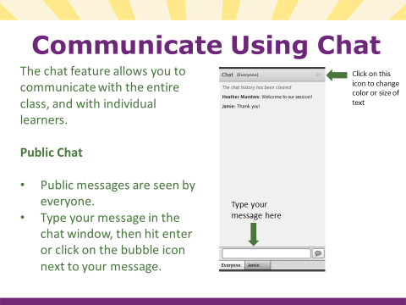  Slide #2 | SAY:  Welcome! We will start off today’s session by helping to get you acquainted with the different communication tools available in Adobe Connect.  SAY:  One way that we can communicate is through chat. In Adobe Connect, you can send public messages to the entire group, as well as private messages to individual learners.  On your screen, you should see a box that says, “Chat (Everyone).” On the upper right corner of that box is an options icon. If you click on the icon, you will see options to change your text size and color. Change your size and color, then go ahead, and send a public chat to everyone. | DO:  Monitor chat, and assist any participants that appear to be having trouble.
Slide/Page | Facilitator | Producer
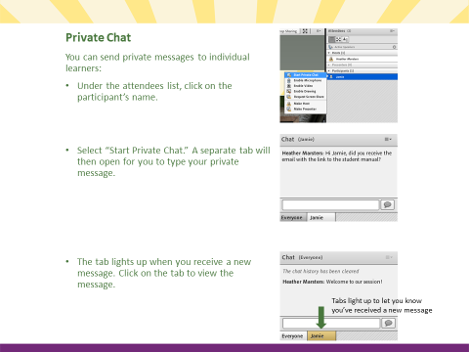  Slide #3  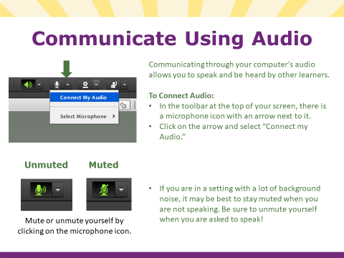  Slide #4 | SAY:  You can also send private chats. Under the attendees list, click on a participant’s name and send them a private chat.  There will be a separate tab for each chat, and the tab will light up to let you know if you receive a new message.  Clicking on the tab will allow you to view the message and respond.  SAY:  Another way to communicate is through audio. In the toolbar at the top of your screen, there is a microphone icon with an arrow next to it. Click on the arrow; scroll down to select the microphone you will be using. Then, click on the arrow and select “Connect my Audio.”  - Option 1 (smaller classes): “Go ahead and do that, and make sure your microphone is on and not muted. Make a sound or say something to test your audio.”  - Option 2 (larger classes): Connect your audio and switch the setting to mute. You will get an opportunity to test our mic when we do introductions.  If you are in a setting with a lot of background noise, it may be best to stay muted, but remember to unmute yourself when you are asked to speak. You can mute and unmute yourself by clicking on the microphone icon.
Slide/Page | Facilitator | Producer
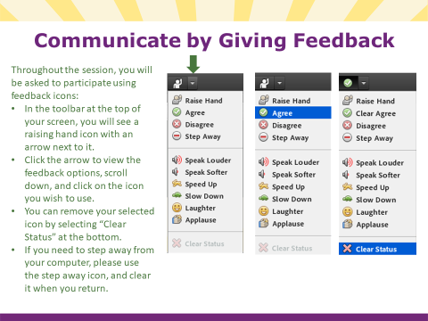  Slide #5 | SAY:  You may be asked to respond using feedback icons. In your menu bar at the top, there is a raised hand icon with an arrow to the right of it. Click the arrow to view the feedback options, then scroll down and select one.  We will be using the green checks/agree and red X/disagree tools frequently.  I also ask that you use the “Step Away” tool when you need to step away from your computer for any reason and during our breaks. When you return, be mindful to “Step In.”  There are additional icons. Feel free to use those to provide feedback throughout the class.  SAY:  You can also clear your icon. In the menu, scroll down and select “clear status” to remove your selected icon. | DO:  Look for participants to respond with feedback.  DO:  Make sure everyone’s status is cleared before moving on.
Slide/Page | Facilitator | Producer
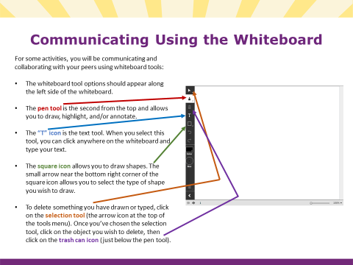  Slide #6 | SAY:  For some activities, you will be asked to communicate using whiteboard tools.  Along the side of your screen, you should see the whiteboard tool options.  The pen tool allows you to draw. The small arrow on the bottom right of the pen icon allows you to select different drawing tools (pen, pencil, marker, or highlighter). Once you have selected a drawing tool, you should see that you also have options to change the color and size. Use a drawing tool to draw something on the whiteboard.  There is also a text tool, which is the letter “T” icon. If you select this tool, you can type text anywhere on the slide. Select the text tool, then click anywhere on the slide. You now have the option to change the color, size, and font. Type your name anywhere on the slide. Note: You must click away after you’re done typing in order for your text to be visible to other learners. Please note that you must hit “enter” to move to the next line. Otherwise your text will continue across the whiteboard on the same line.  The square icon in the tool bar is a shape tool. The small arrow in the bottom right corner of the icon allows you to choose various shapes (square, circle, line, arrow, star, checkmark, X, etc.) Once you’ve selected a shape, you can change the border, thickness, fill, and opacity. Go ahead and draw some shapes on the slide.  Finally, you can move or delete items on the slide. The selection tool (arrow icon at the very top of the menu) allows you to select an object. Once you have selected an object, you can move it around on the slide by clicking and dragging. Or, you can delete the selected object by clicking the delete tool (trash can icon). Go ahead and move/delete some items. | DO:  Enable whiteboard tools.  DO:  Keep whiteboard tools enabled for next slide.
Slide/Page | Facilitator | Producer
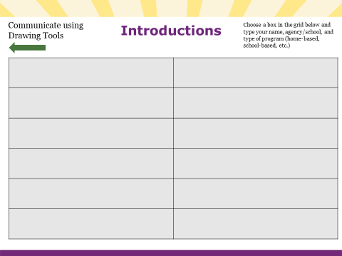  Slide #7 | SAY:  Now that we know how to use our tools, let’s take a few minutes to do some introductions.  Choose a box in the grid and type  - Your name  - the agency/school where you are currently employed, and  - the type of program you work in – home-based, school-based, early-intervention, Day Treatment, HCT, etc.  Be sure to click away after you’ve finished typing, and then give a green check to let us know you’re done.  DO:  After everyone has giving a green check, ask participants to unmute and briefly introduce themselves over audio. Either ask for volunteers or call on people one by one.  DO:  After everyone has introduced themselves, move to next layout: Trainer Introductions | DO:  Make sure whiteboard tools are enabled.  DO:  If people select the same box, direct them to move their text, or move it for them.  DO:  Draw a checkmark next to each participant’s name after they’ve introduced themselves. Assist participants with muting and unmuting if they are having difficulties.  Clear green checks.  Disable whiteboard tools after everyone has introduced themselves.
Slide/Page | Facilitator | Producer
Layout: Trainer Introduction Slides | DO:  Unmute and introduce self over audio (webcam optional).  SAY:  Introduce yourself.  DO:  Move to next layout: Take Aways | DO:  Unmute and introduce self over audio (webcam optional).

Slide/Page | Facilitator | Producer
Layout: Take Aways  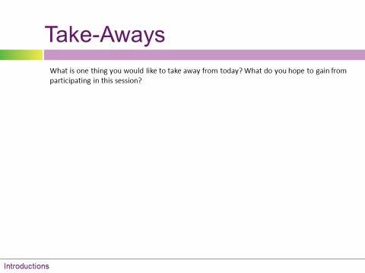  Slide #1 | SAY:  As the facilitator, I’d like to hear from each you regarding your expectations for this class.  What is one thing you would like to take away from today? What do you hope to gain from participating in this session?  DO:  Have participants use whiteboard tools to list one or two things take-aways. Ask them to put their initials next to their responses.  SAY:  Thank you all for coming today. There’s lots of expertise in the room. I’m looking forward to hearing from each of you today! Today is a great opportunity for you to network with other professionals, particularly those of you who work in the home/community setting who likely have limited opportunities to collaborate with your peers.  DO:  Move to next layout: Ground Rules | DO:  Enable whiteboard tools.  DO:  Disable whiteboard tools.

Slide/Page | Facilitator |  | Producer
Layout: Ground Rules  No slide – Ground Rules Chat Box and Ground Rules Note Pod  Day 1  Open the Virtual Classroom  30 minutes prior to the start time.  Learners are encouraged to arrive  10 minutes early to make sure they are able to join and are connected.  Welcome  (Promptly at the start time.)  How to Learn Online  Introductions  Take-Aways  Ground Rules  (approx. 50 minutes for a class size of 12)  10 minute Break  Module 1 (20 mins)  Begin Module 2 (40 mins)  30 minute Break  Finish Module 2 (20 mins)  Module 3 (35 mins)  10 minute Break  Module 4 (55 mins)  Day 2  Welcome Back!  Module 5 (30 mins)  Module 6 (30 mins)  10 minute Break  Modules 7, 8, & 9 (50 mins)  30 minute Break  Module 10 (30 mins)  Module 11 (30 mins)  10 minute Break  Module 12 (25 mins)  Review Take-Aways  Closing Activity  Reminders: CPR/FA/BBP & Eval. | SAY:  Thank you! Before we dive in to our content, let’s take a moment and develop some ground rules for our time together.  Using the chat, type in one or two expectations we can commit to as a group, to create a healthy learning environment.  As adult learners, what guidelines can we agree to, to enhance our time together in this class?  Type those into chat and when you are finished, please give a green check.  DO:  With input from the participants, develop a list of ground rules.  SAY:  You have identified some key ground rules for developing a positive learning culture. (Review their list and add any of the recommended ones below that were not included.)  The virtual classroom is a little different from the traditional classroom.  So we need to use our tools to communicate our body language –  Raising our hands; using the step away icon; muting our microphones when we’re not the one talking, etc.  Just like in the physical classroom, other ground rules that apply are:  - Participate – Step Up/Step Back (if you notice that you haven’t said much, be brave and speak-up; if you notice that you have contributed a lot, step back and give others an opportunity to participate)  - Respect. Things that indicate mutual respect include:  - One person speaks at a time  - Keeping an open mind when you don’t necessarily agree  - Maintain confidentiality  - Be on time when returning from breaks  - Remind participants that sometimes the work we do can trigger certain reactions and that as the day proceeds they should do what they need to do take care of themselves  - Be Present – It is our hope that this class provides an opportunity for each of you to reflect on your personal and professional experience.  Please minimize distractions (turn-off notifications, close other windows, etc.) and resist the temptation to multi-task  - Have fun  Agenda: (See sample agenda in the left column)  DO:  Give a brief overview of your agenda.  We recommend a minimum of a 10-minute break every 55 – 65 minutes.  WFS Virtual Live Days are scheduled for 2 - 4.5 hour blocks of time.  We cover Modules 1 – 4 on the first day and Modules 5 – 12 on the second day.  DO:  Move to next layout: Module 1 |  |  | DO:  Copy ground rules list from chat and paste in note pod titled “Ground Rules.”
Slide/Page | Facilitator | Producer
Layout: Module 1  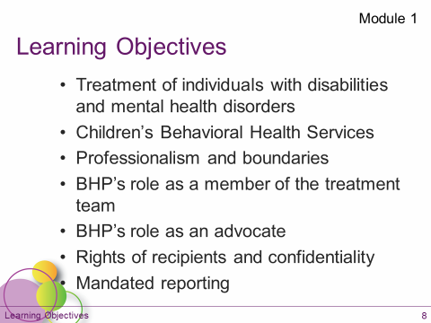  Slide #1  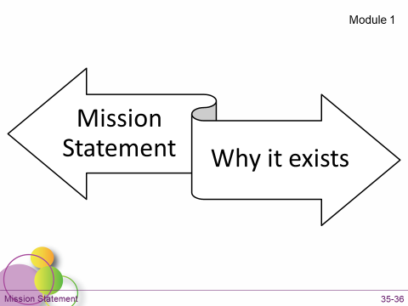  Slide #2 | SAY:  Give me a green  when the Module 1 learning objectives slide has loaded on your screen.  DO:  Wait for everyone to give a green check before moving on.  SAY:  Module 1 of the BHP course is an introduction and an overview of the key concepts of being a BHP. You were required to complete this within 30 days of being hired.  The key learning objectives from Module 1:  - We learned about how individuals with disabilities and mental health disorders have been treated by society in both the past and present and what the current best practices are for serving these individuals.  What are some examples of best practices for serving children and families?  Type in chat an example of a best practice that you employ in your work:  Core principles: providing humane, community-based, individualized treatment that is trauma-informed and culturally competent.  - We reviewed the various children’s behavioral health services that are available through MaineCare Sections 28 and 65. (Student Manual pages 17 – 20)  - You were introduced to:  - documentation and the Individual Treatment Plan (ITP)  - professionalism and boundaries  - your role as a member of the treatment team and as an advocate  - We explored the rights that children and families have as recipients of services including confidentiality, HIPAA & FERPA.  - And we reviewed Mandated reporting and provided a link to the OCFS required Mandated Reporter Training. http://www.maine.gov/dhhs/ocfs/mandated-reporters.shtml. OCFS requires that anyone who is working with children take their Mandated Reporter Training upon hire and complete a refresher once every 4 years.  What questions do you have about any of these topics?  If you have any questions about any of these topics, feel free to type them in the chat.  SAY:  - This morning, we’re going to spend a little time talking about the importance of having a clear mission and vision.  - Organizations develop their mission statements to articulate their aim and core purpose - the reason why they exist.  - Many organizations and individuals begin their meetings or their workday by reading their mission statement to set their focus and to help ensure that their activities stay true to their core purpose. | DO:  Clear green checks.  DO:  Type in chat:  Give an example of a best practice that you employ in your work.  DO:  Monitor chat.

Slide/Page | Facilitator | Producer
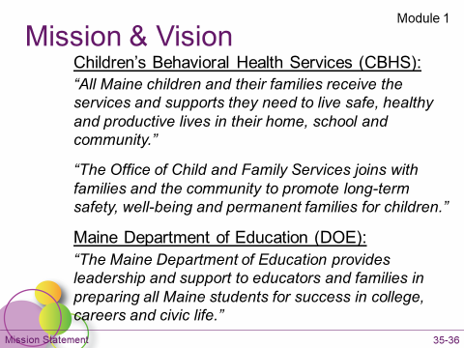  Slide #3  The vision of CBHS:  “All Maine children and their families receive the services and supports they need to live safe, healthy and productive lives in their home, school and community.”  DOE states:  “The Maine Department of Education provides leadership and support to educators and families in preparing all Maine students for success in college, careers and civic life.” | SAY:  As a BHP, the services you provide are an extension of the mission of Department of Health and Human Services (DHHS) and/or the Department of Education (DOE).  Take a moment to read these mission statements. When you are finished, give a green  if these are missions that you feel comfortable aligning yourself with  Or a red X if you don’t feel as though these are consistent with your vision and mission.  DO:  Wait for everyone to respond before moving on. For participants who indicated with a red X, ask them if they are willing to say more.  SAY:  Thank you!  DHHS and DOE are large institutions that serve a wide range of individuals with a variety of needs. As a result, their mission and vision is very broad to encompass everyone they serve.  We’re going to spend the next few minutes, developing our own personal, more specific mission statements. | DO:  Clear green checks.
Slide/Page | Facilitator | Producer
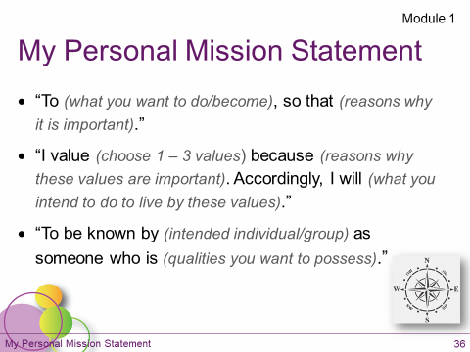  Slide #4  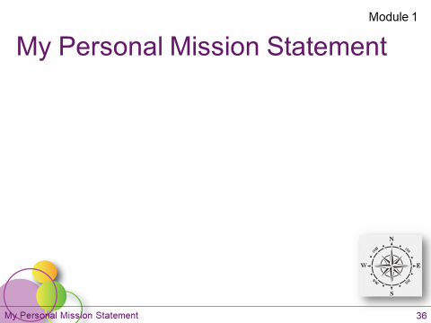  Slide #5 | SAY:  Using the space provided on page 2 of the learning journal or on a separate piece of paper, draft your personal Mission statement as a BHP.  In about 25 words or so, summarize what brings you to this work. There are couple of templates here to help you get started. You are welcome to use one of these or create your own.  DO:  Allow participants 4 – 5 minutes to write their mission statements.  SAY:  Use the whiteboard tools to type a few key words from your mission statement on the slide.  Feel free to put your initials or you can remain anonymous.  Give a green  when you’re done.  DO:  - Thank participants for sharing, and  - Highlight some key words  SAY:  The work you are doing is so important. But it can be challenging. I encourage you to revisit your mission statement from time to time to stay strength-based and be reminded of why you do what you do.  SAY:  What questions do you have about anything that we’ve talked about so far?  Raise your hand or type questions in chat.  PAUSE…  If you don’t have any questions, give a green  to let me know you’re ready to move on. | DO:  Enable whiteboard tools.  DO:  Disable whiteboard tools.  DO:  Clear green checks.  DO:  When everyone has given a green check, clear green checks and move to next layout: Module 2
Slide/Page | Facilitator |  | Producer
Layout: Module 2  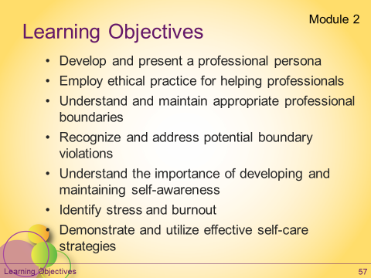  Slide #1 | SAY:  Give me a green check when the Module 2 learning objectives slide has loaded on your screen.  DO:  Wait for everyone to give a green check before moving on.  SAY:  Module 2 focuses on Professionalism.  You are a Behavioral Health Professional.  By definition, a professional is “someone who does a job that requires special training, education, or skill.”  This implies that you are competent in your field of work and act appropriately in your interactions with your clients and colleagues.  This includes developing your professional persona and maintaining healthy boundaries.  Today we are going to review ethics, boundaries, self-awareness and self-care. |  | DO:  Clear green checks.
Slide/Page | Facilitator |  | Producer
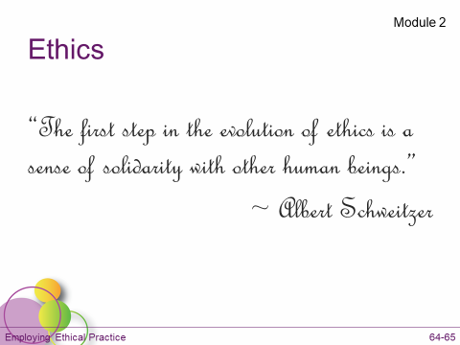  Slide #2 | SAY:  What is the difference between values and ethics?  Type your answers in chat.  DO:  Give participants time to respond and reinforce their answers. If no one answers correctly, give them the answer below:  - There is a difference.  - Values:  - Describe ideas that individuals develop through personal experiences.  - Are prized and individuals likely are emotionally attached to their values.  - Ethics:  - Are standards that guide an individual’s professional decisions and actions in their field of work.  SAY:  Adhering to professional standards is key to your success as a BHP. |  | DO:  Type in chat:  What is the difference between values and ethics?  DO:  Draw separating line in chat.
Slide/Page | Facilitator |  | Producer
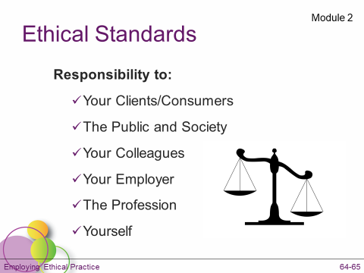  Slide #3 | SAY:  As a BHP, you are a non-licensed professional. The National Organization for Human Services (NOHS) has developed a set of ethical standards that should be adhered to in your work as a BHP.  These standards help to guide your work especially when you are challenged by a difficult situation or decision.  You may also be licensed through, or belong to a professional organization such as the National Education Association or National Association of Social Workers (NASW). If so, you should be familiar with and adhere to that code of professional ethics, which are similar to the ones we are about to review.  DO:  Move to next layout: Ethical Standards Activity

Slide/Page | Facilitator | Producer
Layout: Ethical Standard Activity  No slide  Six chat pods open (one for each ethical standard category)  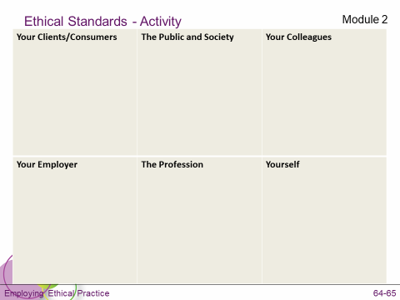 | Instructor’s Note: This activity can be done as either a whiteboard activity or using the chat feature.  If using the whiteboard, simply use the slide with the six categories.  To use the chat, you will need to create a layout with six separate chat pods, one for each category.  For groups of six or more, we recommend dividing participants into smaller groups so the slide doesn’t become too cluttered and all of the categories are discussed.  DO:  Direct participants to brainstorm a list of ways that they uphold the ethical standards in the different categories by typing in the chat pods. Ethical Standards are in file share pod for reference. | DO:  In the Adobe classroom, you can create and title numerous chat pods prior to the start of the class. You will need to move these into the participant area.  DO:  Enable the whiteboard tools, or  Move the chat pod layout to the participant area.

Slide/Page | Facilitator | Producer
Layout: Ethical Standard Activity  Or  No slide - Six chat pods open (one for each ethical standard category) | Examples:  Responsibility to Individuals receiving services (Clients/Consumers)  - Stay strength-based.  - Respect privacy and confidentiality.  - Separate personal thoughts from work to be done.  - Maintain appropriate relationships/boundaries – do not engage in dual relationships.  Responsibility to the Public and Society  - Provide services without discrimination and with cultural competence.  - Stay informed about social issues that may affect children and families.  - Advocate on behalf of those who are not able.  - Be honest regarding qualifications.  Responsibility to Colleagues  - Resolve conflicts in a respectful manner, involving supervisor(s) when necessary.  - Respond appropriately to problematic behavior of colleagues.  Responsibility to Employer  - Help families to understand how the agency functions and its reputation.  Responsibility to the Profession  - Awareness of the scope of both your knowledge and skills.  - Seek out new and effective approaches to your work.  - Be mindful of how you present yourself on social media platforms. (Mention that participants should clarify with their agency the specific policies regarding social media)  Responsibility to Self  - Awareness of personal biases and their effect on working relationships.  - Commitment to lifelong learning and growth of knowledge.  DO:  Reinforce participant responses, then go back to previous layout: Module 2

Slide/Page | Facilitator | Producer
Layout: Module 2 (continued)  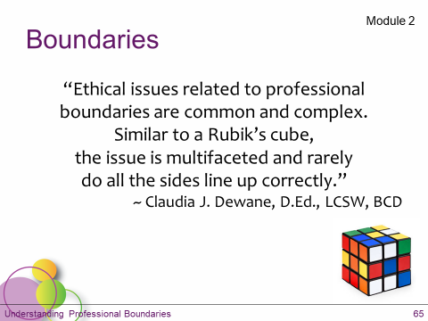  Slide #4 | SAY:  As was discussed in several modules throughout the BHP course, well-constructed and consistently maintained boundaries will support a healthy working alliance with the child and family that you support.  Boundaries are an essential component of your relationship with the child and family that, along with the ethical standards, will guide your interactions.  There is a great quote from a licensed clinical social worker: “Ethical issues related to professional boundaries are common and complex. Similar to a Rubik’s cube, the issue is multifaceted and rarely do all the sides line up correctly.” – Claudia J. Dewane, D.Ed., LCSW, BCD (Respecting Boundaries – The Don’ts of Dual Relationships, Social Work Today, Vol. 10 No. 1 p. 18, 2010.)  Not all boundaries are clearly black or white. There are some gray areas. It’s important to talk with your supervisor whenever you are not sure about where to set a boundary.  Let’s review some of the boundaries that are important for you to maintain.
Slide/Page | Facilitator | Producer
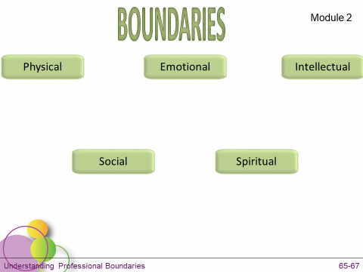  Slide #5 | DO:  Ask participants to list examples of how they set and maintain boundaries in each of the various areas on the slide using whiteboard tools. (Pages 65 & 66 of their student manual.) Depending on class size, you may assign each participant a category, or ask each person to choose 1-2.  DO:  Reinforce participant responses, and add any information that was missed using talking points below:  Examples/Talking Points:  The following examples can be used to start the discussion:  - Physical – personal space, touch  Example: Refrain from hugging someone with whom you have a strictly professional relationship.  Follow the guidelines for the use of physical management procedures as determined by DHHS licensing and/or DOE rules (specifically chapter 33) and BHPs and your organization’s policies.  - Emotional – how people share and express their feelings  Example: Be careful not to overshare. Don’t invalidate feelings by saying, “don’t be sad/mad/etc.” Be careful not to promote emotional dependency on you or other service providers.  - Intellectual – respecting and adapting to how the child or family member processes information  Examples: Be careful not to tell an individual that their view is wrong, or make someone feel badly for the way they interpret things; Take responsibility for your actions; Be mindful and limit the use of acronyms related to special education or clinical terminology to ensure that the child/family understand.  - Social – the limits of our relationships with others  Examples: How do you handle it when:  - a child or family member sends you a Facebook friend request?  - you are invited to a family party or outing?  - you encounter the child and family at the grocery store or other public setting?  What is appropriate regarding non-service related interactions with the child and family such as: dating a family member, going into business with a family member, or other types of dual relationships with the child and his or her family?  In general, these types of interactions or relationships between clients and service providers are strongly discouraged because it increases the opportunity for exploitation.  - Spiritual – how people express spiritual/religious beliefs  Examples: Respecting the child and/or family’s spiritual beliefs and practices. Don’t attempt to alter an individual’s personal belief/faith system, i.e. having a discussion regarding religious/political beliefs in which one participant is trying to change the way the other thinks. | DO:  Enable whiteboard tools.  DO:  Keep whiteboard tools enabled for next activity.

Slide/Page | Facilitator |  |  | Producer
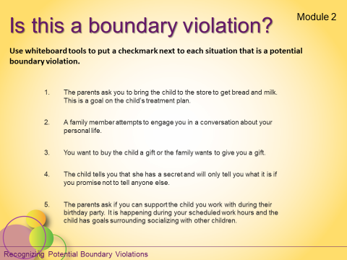  Slide #6 | SAY:  Which of these are potential boundary violations? Put a checkmark next to each potential boundary violation.  DO:  Wait for participants to respond before discussing answers below. When discussing, ask participants:  “Why is this a boundary violation? Let me know in chat,” or  “Give a green check if you’ve been in a situation similar to this” - then call on someone who gave a green check and ask them to share over audio.  - BHP is asked to bring the child to the store to get bread and milk. This is a goal on the child’s treatment plan.  Since it is a goal in the treatment plan, this would not be a boundary violation.  - Sharing of personal information: BHP shares personal information with the child or family member, or the family member attempts to engage the BHP in a conversation about their family life.  Before you share personal information, ask yourself, “Whose needs are being met if I share this information?” This could be a potential boundary violation.  - You want to buy the child a gift.  Discuss the difference between being friends and being friendly. Buying gifts is something friends do, saying “happy birthday” is a friendly gesture. As a BHP, you are friendly, not a friend.  - The child tells you that she has a secret and will only tell you what it is if you promise not to tell anyone else.  Tell the child that you can’t keep the secret if it is a health or safety issue (tell them this immediately, before they tell you the secret, so that if you do need to report it, you haven’t violated their trust).  - The parents invite you to the child’s birthday party, and it is happening during your scheduled shift.  If this is happening during work shift and you will be working on treatment goals, this would not be a boundary violation. |  |  | DO:  Make sure whiteboard tools are enabled.  DO:  Disable whiteboard tools.
Slide/Page |  | Facilitator | Producer
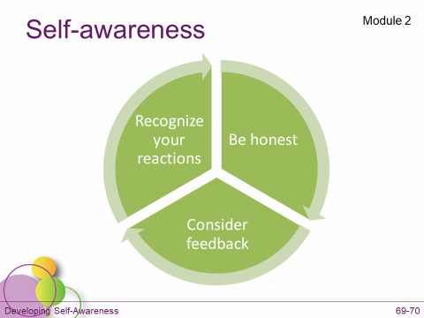  Slide #7  Slide is animated |  | SAY:  What is self-awareness and why is it important to your work as a BHP? Type your answers in chat.  DO:  Give participants time to respond, then click the animation.  SAY:  Self-awareness is:  - Being aware of your verbal and non-verbal reactions to things like: stress, surprises, compliments, criticism, etc.  - As a BHP, you can experience these on any given day, yet you must always present yourself as a professional.  - You must be aware of your reactions, including those that may happen unconsciously, including your tone of voice and body language.  - Being emotionally and intellectually honest about your feelings and judgement. We all have individual values that are deeply ingrained in us which may make it difficult to adhere to ethical standards and remain objective in particular situations. It is important that we recognize these.  - Seeking and accepting feedback from others about how they perceive you and your behaviors will help you develop greater self-awareness.  This should be a continuous process for becoming increasingly self-aware. | DO:  Type in chat:  What is self-awareness and why is it important to your work as a BHP?  DO:  Put separating line in chat.
Slide/Page |  | Facilitator | Producer
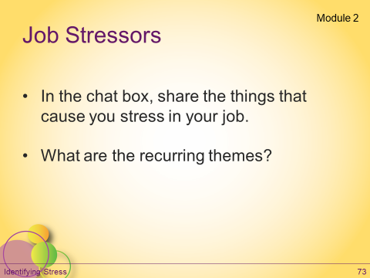  Slide #8 |  | SAY:  As we discussed in the online modules, self-awareness is also important as it relates to recognizing when and how you are stressed.  The job that BHPs are tasked with can be emotionally and physically draining with a variety of different stressors.  DO:  Ask participants to share in chat some things that are stressful about being a BHP. If class size is large, assign pairs and have participants use the private chat feature. Then ask pairs to share with the large group either in chat or over audio.  Possible answers:  - The nature of the work  - Dealing with people’s lives and the challenges they face  - Managing the child’s difficult or challenging behavior, which may be unpredictable or may cause staff injuries  - BHPs may experience a discrepancy between their skill level and their job description  - Low expectation + highly skilled = boredom or frustration  - Expectations that exceed their skill level = feeling overwhelmed  - Using the work to satisfy personal needs  - The sense that the BHP is more invested in the child’s progress than the child or their caregivers  - Many BHPs work more than one job, experiencing long hours and limited time off  - May feel isolated or a lack of adequate support and training from a supervisor  - Failing to live up to their own expectations for effectively supporting the child and family | DO:  Type in chat:  What causes you stress in your job?  DO:  Put separating line in chat.
Slide/Page |  | Facilitator | Producer
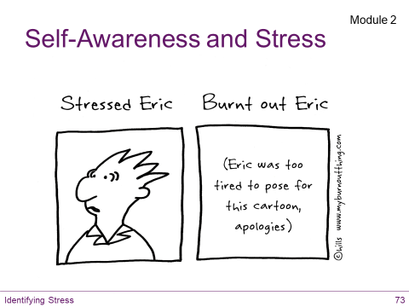  Slide #9  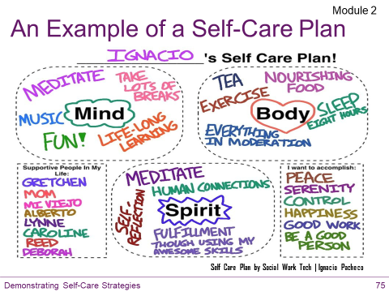  Slide #10 |  | SAY:  There is a difference between stress and burnout.  “Burnout” is a term used to describe the various types of symptoms associated with stress that helping professionals experience.  It is “the cumulative psychological strain of working with many different stressors” (Dart Center, n.d.).  Stress is inevitable. Burnout can be avoided.  Symptoms that someone experiencing burnout may exhibit include (see page 73 of student manual): emotional/physical exhaustion, depression, cynicism, boredom, loss of empathy, and discouragement.  SAY:  Developing strategies to care for your own physical, mental, and emotional needs will minimize the negative impact stress can have.  How many of you remember Ignacio’s video from module 2 online? Give a green check if you remember it.  DO:  Wait for participants to respond. If participants give green checks, ask if any are willing to share something they took away from it either in audio or in chat. | DO:  Clear green checks.
Slide/Page |  | Facilitator | Producer
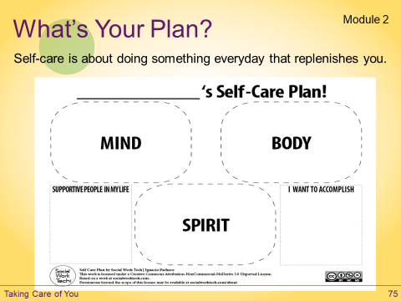  Slide #11 |  | DO:  Have participants turn to the self-care plan on page 3 of the learning journal.  Instruct them to use whiteboard tools to type on the slide one self-care strategy they are currently using, or one that they plan to use in the future.  Remind participants that their supervisors can be a great resource for helping them effectively manage their responsibilities as a BHP.  SAY:  What questions do you have about module 2? Raise your hand or type questions in chat. If you don’t have any questions, give a green check to let me know you’re ready to move on.  DO:  When everyone has given a green check, move to next layout: Module 3 | DO:  Enable whiteboard tools.  DO:  Clear green checks and disable whiteboard tools.

Slide/Page | Facilitator | Producer
Layout: Module 3  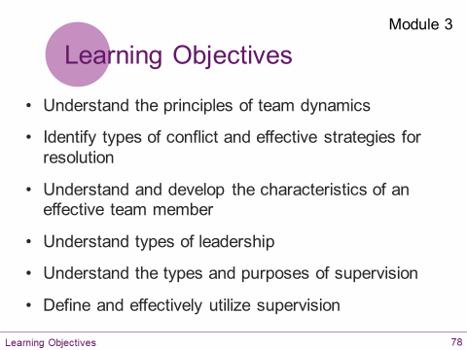  Slide #1 | SAY:  Give me a green  when the Module 3 learning objectives slide has loaded on your screen.  DO:  Wait for everyone to give a green check before moving on.  SAY:  Module 3 is all about working as a team.  The child’s Individual Treatment Plan (ITP), along with the Individual Education Program (IEP) for those of you who are working in the school setting, is the blueprint for the Treatment Team and guides each team members’ work.  It is important that you have an understanding of team dynamics, as a key member of the treatment team, and develop strategies for being an effective team member.  Let’s review some of the core concepts from module 3, beginning with supervision. | DO:  Clear green checks.
Slide/Page | Facilitator |  | Producer
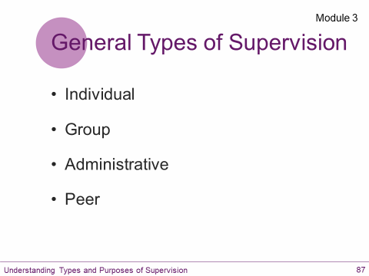  Slide #2  Slide is animated | SAY:  There are multiple approaches to supervision. In your work, you may be asked to participate in various types of supervision in order to ensure that goals are being addressed.  Who remembers what the four types of supervision are that were discussed in module 3? Raise your hand if you remember any of the four types.  DO:  Call on anyone who raised their hand to share over audio, reinforce their responses, then advance slide animations and go over information below:  These first two are considered clinical supervision, meaning that the focus is on the work that you and the treatment team are doing with the child and family.  - Individual - 1 on 1 with supervisor, focus is on delivery of service and your professional development as a BHP.  - Group - BHPs meet, supervisor facilitates, and the focus is on delivery of service, collaborating to employ best practices.  - Administrative – Focus is on job expectations, scheduling, vacation time, benefits, etc.  - Peer - BHPs meet, discuss issues related to work, offer support. This is an informal form of supervision.  MaineCare regulations for section 28 state that BHPs “employed full time must be supervised a minimum of 4 hours per month.” BHPs working part-time “must receive a prorated number of hours of supervision, with a minimum requirement of 1 hour per month.”  MaineCare regulations for section 65 do not specify the number of hours of supervision required. BHPs working in Section 65 provide intervention services to the member and family under the direct supervision of a clinician.  The Department of Education also has regulations for the supervision of Ed. Techs. that apply to BHPs working in school programs while in the classroom or in community-based school programs.
Slide/Page | Facilitator | Producer
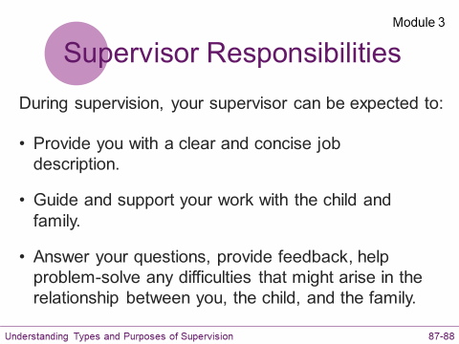  Slide #3  Slide is animated | SAY:  During supervision, your supervisor can be expected to:  - Provide you with a clear and concise job description – helping you to define and redefine your responsibilities and the expectations and limitations of your role.  - Guide and support your work with the child and family.  - Answer your questions, provide feedback, and help problem-solve any difficulties that might arise in the relationship between you, the child, and the family.
Slide/Page | Facilitator | Producer
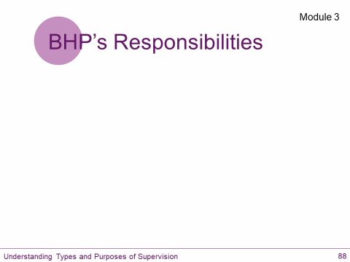  Slide #4 | DO:  Ask participants to brainstorm suggestions for what their responsibilities are during supervision and to put their answers on the slide using whiteboard tools.  After participants review the following 4 components:  - Articulation - Clearly communicate your needs and wants. Request guidance and support with specific issues.  - Organization - Your observations and questions should be thoughtful and prepared. Bring ideas for addressing challenges.  - Self-awareness - The ability to identify strengths, as well as areas in need of professional development.  - Openness - You should be receptive to feedback and be willing to provide input.  SAY:  It is also important to know when to seek additional, unscheduled supervision. If you have health or safety concerns regarding the child you support or a member of the child’s family, or if you feel unsafe for any reason, you should excuse yourself and contact your supervisor immediately. When in doubt, ask your supervisor! | DO:  Enable whiteboard tools.  DO:  Keep whiteboard tools enabled for next activity.
Slide/Page | Facilitator | Producer
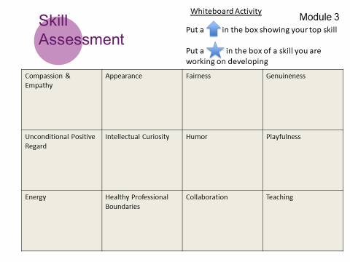  Slide #5 | SAY:  It is clear from our discussions so far that all of you have strengths and talents that you bring to your work.  This next activity gives you an opportunity to assess some of the core skills needed to be an effective BHP.  DO:  Have participants turn to page 4-5 in the learning journal: Skill Assessment.  Review the instructions:  On a scale of 1 to 5 (1 being ineffective and 5 being very effective) rate yourself on each skill listed.  Then, on the next page, Identify one skill that you would like to develop and write an action plan for improvement.  Give participants 5 minutes to complete the assessment and their plan for improvement.  Give a green  when you’re ready.  Using the text tools,  put an arrow in the box that corresponds to your top skill,  and a star in the box for a skill you identified that you want to work on developing.  Who would be willing to say more about their top skill?  Please raise your hand.  ____________, thank you! Unmuting your audio, please share.  Thank participants for sharing. | DO:  Make sure whiteboard tools are enabled.  DO:  Disable whiteboard tools.
Slide/Page | Facilitator | Producer
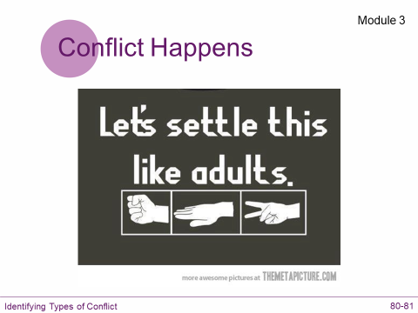  Slide #6 | SAY:  Even the most skilled professionals and dynamic teams experience conflict. Similar to stress, conflict is unavoidable.  How many of you have experienced conflict among team members?  Give a green  if you’ve been part of a team that has experienced conflict.  DO:  Wait for participants to respond.  Ask people who gave green checks to share what that was like, either in chat or over audio using the hand-raising tool.  SAY:  One key to effective team membership is managing conflict when it arises.  Typically, conflict occurs when the needs, wants, or values of individuals are incompatible with others.  Even though it may be less than comfortable, what are some possible benefits of conflict? Type your answers in chat.  DO:  Allow participants to respond and reinforce their responses.  SAY:  While conflict cannot be avoided entirely, it does serve a purpose and can be an opportunity  - to make progress,  - develop solutions,  - engage in meaningful conversations,  - and deepen our understanding of others.  SAY:  What are some strategies that you have found to be effective in resolving conflict? Type your answers in chat.  DO:  Allow participants to respond and reinforce responses.  SAY:  When there is conflict, team members need to be respectful toward one another. When handled professionally, the process of resolving the conflict is a growth opportunity for all involved that may ultimately benefit the child you are working with. | DO:  Clear green checks.  DO:  Type in chat: What are some possible benefits of conflict?  DO:  Type in chat:  What are some strategies that you have found to be effective in resolving conflict?  DO:  Put separating line in chat.

Slide/Page | Facilitator | Producer
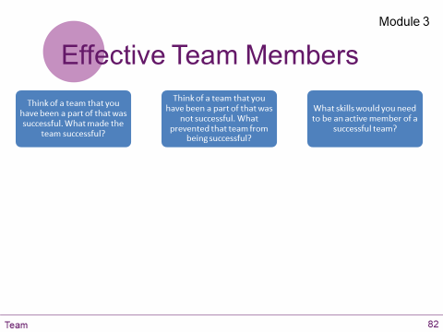  Slide #7 | SAY:  Take a moment to consider these questions:  - Think of a team that you have been a part of that was successful. What made the team successful?  - Think of a team that you have been a part of that was not successful. What prevented that team from being successful?  - What skills would you need to have to be an active member of a successful team?  Using the whiteboard tools, jot down your thoughts on one of the questions on the slide.  Review their responses.  SAY:  What questions do you have about module 3?  Raise your hand or type questions in chat.  Give a green check to let me know you’re ready to move on.  DO:  When everyone has given a green check, move to next layout: Module 4 | DO:  Enable whiteboard tools.  DO:  Disable whiteboard tools.  DO:  Clear green checks.

Slide/Page |  | Facilitator | Producer
Layout: Module 4  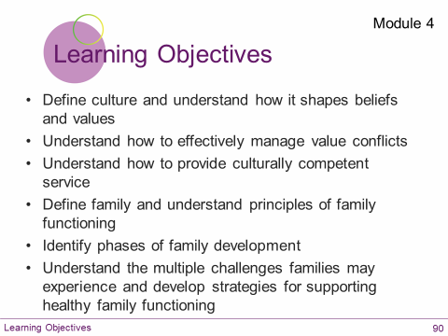  Slide #1 |  | SAY:  Give a green  when the Module 4 learning objectives slide has loaded on your screen.  DO:  Wait for everyone to give a green check before moving on.  SAY:  In module 4 we discuss what it means to be culturally competent and why that is so important.  We also talk about how each family has its own unique culture, and we discuss the dynamics of family functioning.  Those of you working in a home setting have a front row seat to how the family operates.  Those of you who work in the school setting may be a bit more removed, but it is likely that you have some insight into what the child’s family is like based on your interactions with the student.  Today, in an effort to increase our cultural competency, we are going to do a couple of activities to better understand culture and its impact.  We are also going to review some of the challenges many of the families that we work with are coping with and how as a BHP, you can best support healthy family functioning. | DO:  Clear green checks.
Slide/Page |  | Facilitator | Producer
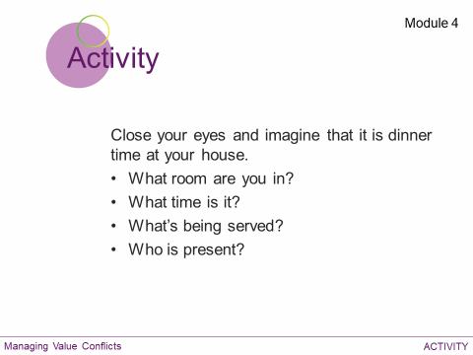  Slide #2  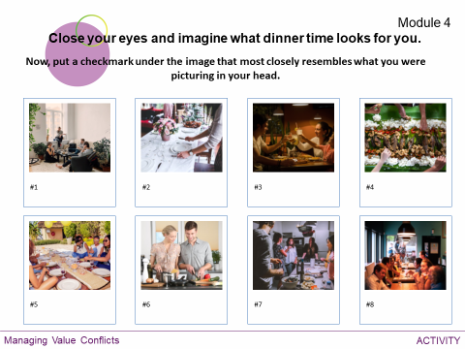  Slide #3 |  | DO:  Ask participants to close their eyes and picture what dinnertime looks like at their house.  DO:  Ask participants to put a checkmark in the box containing the image that most closely resembles what they were picturing.  SAY:  Did anyone here ever go to dinner at a friend’s house?  What was that like? Were there differences between your experience at home and at a friend’s house?  Share your answers in chat.  DO:  Review responses.  SAY:  What’s the right way to eat dinner? Answer in chat.  DO:  Review responses.  SAY:  There is no right way. We need to remember that based on how we grew up, we likely have opinions about how things should be done, but we need to be sensitive to everyone’s culture.  People do what works for them. Our culture – our values, beliefs, traditions, etc. – are ingrained in us in such a way that we don’t even think about it.  We need to make sure that we are not forcing our beliefs on the children and families we support, or judging them for their beliefs.  Not everyone has the same values and that’s okay. | DO:  Enable whiteboard tools.  DO:  Type in chat:  Was it different eating dinner at a friend’s house? What was different about it?  DO:  Type in chat:  What’s the right way to eat dinner?  DO:  Put separating line in chat.  Keep whiteboard tools enabled for next slide.
Slide/Page |  | Facilitator | Producer
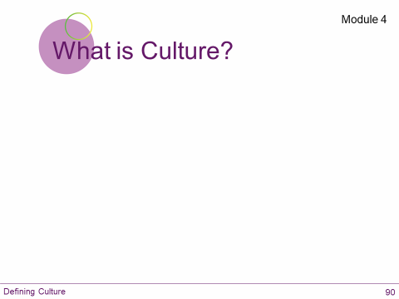  Slide #4  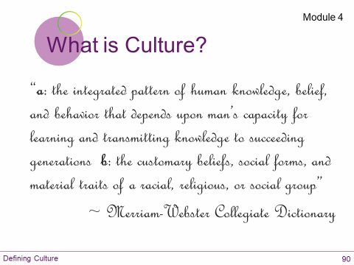  Slide #5 |  | SAY:  What comes to mind when you hear the word “culture?” Use whiteboard tools to type words/phrases that pop in your head when you hear the word culture.  DO:  Review responses.  DO:  Read the definition. | DO:  Make sure whiteboard tools are enabled.  DO:  Disable whiteboard tools.
Slide/Page |  | Facilitator | Producer
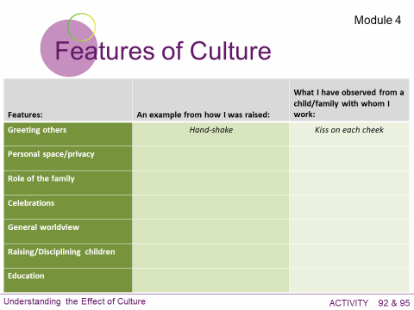  Slide #6  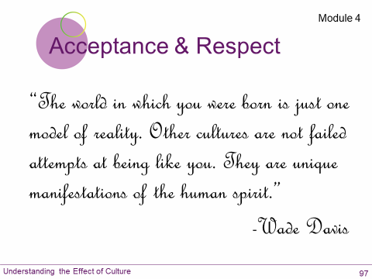  Slide #7 |  | SAY:  Turn to page 6 of your learning journal.  Choose 3 or 4 of the features of cultures and record one or two examples common to your family while you were growing up.  Then for the same features you chose, record one example common to the families with which you work (to the best of your knowledge).  DO: PAUSE 2 – 3 minutes.  SAY: Give a green  when you're ready.  Using whiteboard tools, pick one feature and share what you wrote.  DO:  Ask for a volunteer (using hand raising tool), or assign people to work on certain features.  Review differences on lists.  SAY:  When faced with potential value conflicts, please keep in mind that value conflicts are more than just a difference of opinion. They involve emotions and what a person believes is truly right and wrong. This can make it difficult to be objective. | DO:  Enable whiteboard tools.  DO:  Disable whiteboard tools.
Slide/Page | Facilitator |  |  | Producer
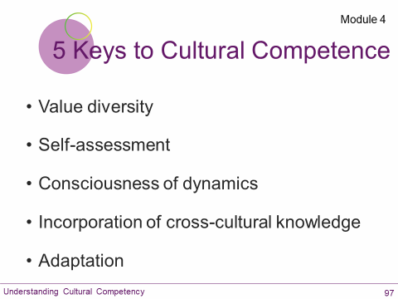  Slide #8 | DO: Review the 5 keys to cultural competence using information below:  - Value Diversity – Accept and respect differences.  Are you curious about the child’s culture? What can you learn from how they do things? Embracing diversity is an opportunity for personal and professional growth.  - Self-Assessment – Understanding of initial judgments regarding a different culture due to stereotypes or experiences.  Do you have insight into your beliefs and biases and how these influence your behaviors? Are you able to set aside your preconceived ideas and get to know the child as an individual?  - Consciousness of Dynamics – Awareness of factors affecting cross-cultural interactions.  When conflicts arise, do you consider how the cultural expectations of the individuals involved may be affecting the situation?  Can anyone think of an example? Type your thoughts in chat.  EX: How do we view eye contact? Respectful, giving them your attention. But some cultures view eye contact as a disrespectful and challenging behavior. How might this create a problem?  - Incorporation of Cross-Cultural Knowledge – Learning about the cultures of the individuals you serve.  Are you incorporating the knowledge gained through cross-cultural experience into your practices? As part of your professional development, are you continually learning about the culture of the children and families you serve?  - Adaptation – Changing methods and activities to fit cultural norms.  When you are aware of a cultural norm, are you willing to modify your behavior to fit in? In your role as a BHP, are there deal breakers when working with a family? If so, how will those be communicated?  DO:  Consider taking a moment to discuss the possibility of deal breakers for BHPs. There may be specific things that a particular BHP finds extremely challenging to overcome (working in a smoking household when the BHP has asthma, or working with a student who uses hate speech in reference to the BHP’s race, religion, sexual orientation, etc.)  Instructors should mention that there is a distinct difference between preferences and deal breakers. BHPs can expect to have to make reasonable adaptations to meet the needs of children and families, while deal breakers are those situations where adaptation is not a feasible option and the services being provided to the child are compromised as a result. |  |  | DO:  Type in chat:  Can you think of an example in which cultural expectations of individuals may have affected a situation or led to a conflict?
Slide/Page |  | Facilitator | Producer
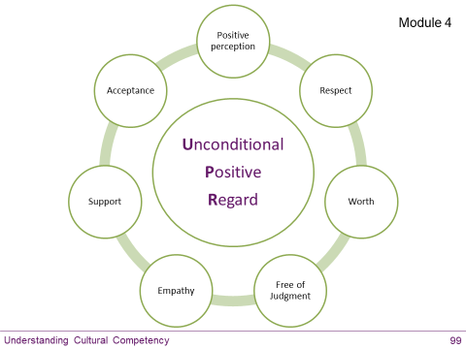  Slide #9 |  | SAY:  Unconditional Positive Regard is an essential component for developing your cultural competency and providing culturally competent services.  Unconditional Positive Regard serves as the cornerstone for the development of a respectful relationship with the child and family.  Assumptions and generalizations about unfamiliar groups are sure to be damaging to the relationship between you and the families you support.  You can work to avoid this by making an effort to learn more about the culture of each individual child and their family.  Unconditional Positive Regard also helps us to remember that most of the time, families are doing the best they can with the resources they have within their current situation.
Slide/Page |  | Facilitator | Producer
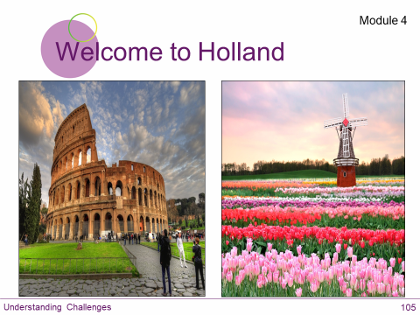  Slide #10  Slide is animated |  | SAY:  Emily Perl Kingsley is a writer and a mother to a son with Down syndrome. Her experience of having a child with a developmental diagnosis is chronicled in a short essay she wrote called, “Welcome to Holland.” Her essay often resonates with caregivers who are struggling with their child’s diagnosis and the emotions that accompany the process. Keep in mind, though, that this may not resonate with all parents.  The essay is on page 7 in your learning journal if you’d like to follow along.  I am often asked to describe the experience of raising a child with a disability - to try to help people who have not shared that unique experience to understand it, to imagine how it would feel. It's like this...  When you're going to have a baby, it's like planning a fabulous vacation trip - to Italy. You buy a bunch of guide books and make your wonderful plans. The Coliseum. The Michelangelo David. The gondolas in Venice. You may learn some handy phrases in Italian. It's all very exciting.  After months of eager anticipation, the day finally arrives. You pack your bags and off you go. Several hours later, the plane lands. The stewardess comes in and says, "Welcome to Holland."  "Holland?!?" you say. "What do you mean Holland?? I signed up for Italy! I'm supposed to be in Italy. All my life, I've dreamed of going to Italy."  But there's been a change in the flight plan. They've landed in Holland and there you must stay.  The important thing is that they haven't taken you to a horrible, disgusting, filthy place, full of pestilence, famine, and disease. It's just a different place.  So, you must go out and buy new guide books. And you must learn a whole new language. And you will meet a whole new group of people you would never have met.  It's just a different place. It's slower-paced than Italy, less flashy than Italy. But after you've been there for a while and you catch your breath, you look around... and you begin to notice that Holland has windmills... and Holland has tulips. Holland even has Rembrandts.  But everyone you know is busy coming and going from Italy... and they're all bragging about what a wonderful time they had there. And for the rest of your life, you will say "Yes, that's where I was supposed to go. That's what I had planned."  And the pain of that will never, ever, ever, ever go away... because the loss of that dream is a very, very significant loss.  But... if you spend your life mourning the fact that you didn't get to Italy, you may never be free to enjoy the very special, the very lovely things... about Holland.  SAY:  What are your thought/reactions to this essay? Let us know in chat.  DO:  Review participant responses.  SAY:  Coming to terms with their child’s diagnosis and challenges may affect a caregiver’s ability to engage with service providers and treatment from time to time.  Each caregiver will respond and adapt in their own way and at their own pace.  Feelings of loss and grief may reappear at times when certain milestones are not met at the expected stage of development and/or are not likely to be met at all depending on the child’s needs. | DO:  Advance animation when windmills and tulips are referred to.  DO:  Type in chat:  What are your thoughts/reactions about "Welcome to Holland?"  DO:  Put separating line in chat.

Slide/Page | Facilitator |  |  | Producer
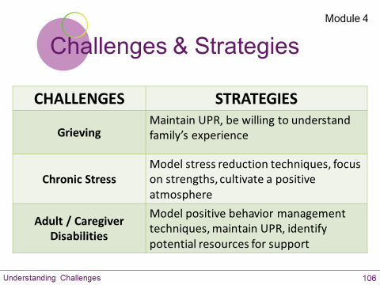  Slide #11 | DO: Review the information:  Challenge: Grieving – As we have just heard in Welcome to Holland, caregivers may experience grief at various stages in their child’s development; grieving the loss of milestones that their child may not reach or experience at the same time as some of their peers.  Strategies: Maintain unconditional positive regard, be willing to understand the family’s experience. Bring any concerns you have about how the family is functioning to your supervisor.  Challenge: Chronic Stress – All caregivers and families experience stress. Chronic stress comes from constant demands and pressure for extended periods of time without adequate relief. This can cause fatigue, illness, and feelings of hopelessness. Day-to-day tasks can become overwhelming because there is too much to attend to. Families with children who are receiving services typically have increasing demands. The additional time, attention, and financial resources needed to meet their child’s needs can become part of the chronic stress these families experience. The stress of dealing with various behavioral challenges and the inherent concerns that parents have about their child’s well-being when he or she is acting out are stressors as well.  Strategies: Model stress reduction techniques, focus on strengths, cultivate a positive atmosphere.  Challenge: Adult / Caregiver Disabilities – Caregivers and other family members may be dealing with their own challenges. Developmental disabilities, mental health disorders, and/or chronic health issues may impair a caregiver’s ability to effectively engage in treatment.  Strategies: Model effective behavior management techniques and unconditional positive regard. With the treatment team, identify additional resources and supports for the family to access.
Slide/Page | Facilitator |  |  | Producer
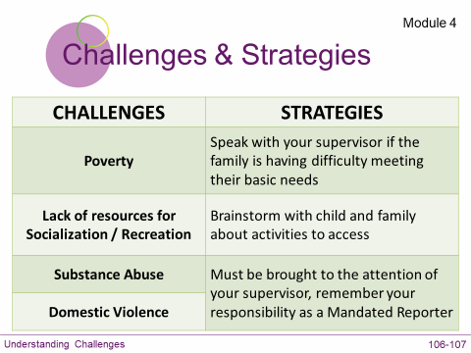  Slide #12 | Continued…  Challenge: Poverty – Many families struggle to make ends meet for a variety of reasons. Caregivers may have difficulty managing full-time employment and attending to the special needs of their child. The poverty rate is higher among single-parent households than two-parent homes. According to the USDA Food and Nutrition Service, in 2015 about 1 in every 5 children lived in poverty.  Strategies: The treatment team may be able to provide the family with additional resources to meet their basic needs.  Challenge: Lack of Social Supports – Families often feel alone; as though there are few who truly understand their situation. They may also not be aware of supports within their community. This can lead to feelings of isolation.  Strategies: Brainstorm with child and family about activities to access. Help identify natural supports.  Sometimes families have complex issues that need to be brought to your supervisor or may rise to the level of involving Child Protective Services. (Note: substance abuse and domestic violence do not necessarily occur together.)  Challenge: Substance Abuse – you may encounter a parent, caregiver, or other family member who is dealing with addiction.  Substance abuse can impair a caregiver’s ability to provide the proper care and supervision their child needs, putting the child at risk.  According to Maine’s Community Partnerships for Protecting Children (CPPC) parental Substance Use Disorder is one of the top family stressors that brings children into the care of Child Protective Services  Challenge: Domestic Violence – it is possible that the child is living in a home where there is domestic violence. “Domestic violence is a pattern of assaultive and coercive behaviors that adults or adolescents use against their current or former intimate partners.” (Missouri Coalition Against Domestic Violence.) Witnessing domestic violence or living in a home where domestic abuse is happening can have detrimental effects on children.  Strategies: Any concerns you may have about substance abuse or domestic violence within the home you are working should be brought to your supervisor’s attention. Remember that all BHPs are Mandated Reporters and concerns regarding either of these issues may rise to the level of warranting a report being filed. Unconditional Positive Regard does not mean that you overlook circumstances in which a child’s safety and well-being are in jeopardy.  SAY:  What questions do you have about module 4? Raise your hand or type questions in chat. If you don’t have any questions, give a green  to let me know you’re ready to move on.  This is the end of Day 1 of virtual training.  Please watch this 12-minute TedTalk before the start of class tomorrow.  We will see you tomorrow for Day 2!  DO:  Close out of room, but don’t clear any annotations or pods until the end of Day 2 in case you decide to revisit anything during the next session. |  |  | DO:  Type the link to Shawn Achor’s Happiness Advantage TedTalk in chat and/or email the link to participants.
https://www.ted.com/talks/shawn_achor_the_happy_secret_to_better_work?language=en
Slide/Page |  | Facilitator | Producer
Layout: Welcome Back  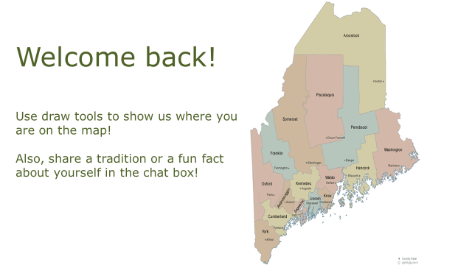  Slide #1 |  | DO:  Welcome participants into the virtual classroom and invite them to participate in the opening activities (whiteboard activity, chat question, and poll question).  Point out that the student manual and learning journal are in the file share pod and available for download if participants weren’t able to download those materials prior to class.  When it’s time to begin class, advance to the next layout: Module 5 | DO:  Enable microphones for the participants. (In menu bar, click on “Audio,” scroll down and ensure that microphone rights for participants is enabled.)  Assist any participants that are having trouble getting into the classroom.

Slide/Page |  | Facilitator | Producer
Layout: Module 5  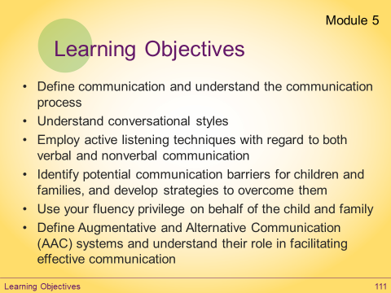  Slide #1  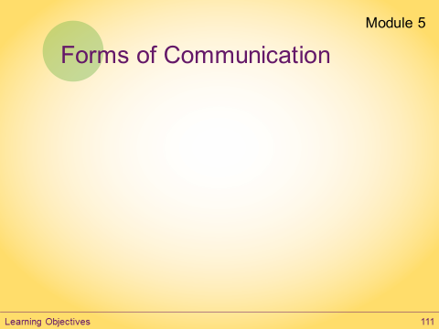  Slide #2 |  | SAY:  Give me a green check when the Module 5 learning objectives slide has loaded on your screen.  DO:  Wait for everyone to give a green check before moving on.  SAY:  Module 5 is all about communication.  Communication is more than talking and listening.  SAY:  Many of you work with children who communicate in ways other than verbally.  What other forms of communication do the children you work with use? Use whiteboard tools to add your answers to the slide.  DO:  Wait for participants to respond, then add any answers they missed using information below:  - Body Language/Nonverbal  - Facial Expressions  - Behavior  - ASL (American Sign Language)  - Written  - Gestural/VGC  - Alternative/Augmentative Communication  - PECS (Picture Exchange Communication System)  SAY:  Today we are going to do a couple of exercises to help us improve communication and overcome potential barriers. | DO:  Clear green checks.  DO:  Enable whiteboard tools.  DO:  Disable whiteboard tools.
Slide/Page | Facilitator |  |  | Producer
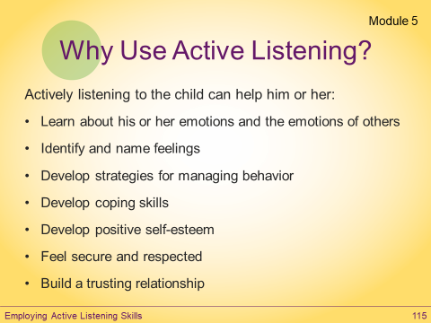  Slide #3 | SAY:  How many of you can recall a time when you were trying to talk to someone and they were clearly not listening... What was that like? What were they doing? How did that make you feel?” Type your answers in chat.  DO: Allow participants to respond and comment on their responses.  SAY:  So what is Active Listening? What does that mean? Active listening means giving your full attention to hearing and understanding what someone is saying to you; trying to fully understand what the child is saying to you.  Can you be an Active Listener while you are checking your phone for text messages or using social media? Green check for yes, red X for no.  DO: Wait for participants to respond.  SAY:  Can you be an active listener if you're thinking about what you're going to do after work? Green check for yes, red X for no.  DO:  Wait for participants to respond.  SAY:  Active Listening doesn’t necessarily take a long time. It does require effort and at times it may not come easy. But it's worth it!  So why is it important that you as BHPs use Active Listening?  DO: Read slide aloud.  SAY:  Developing active listening skills will help you, as a BHP, better understand the child and family you are supporting, and do your job more effectively. |  |  | DO:  Type in chat:  Can you recall a time when you were trying to talk to someone and they clearly were not listening? What was that like?  DO:  Clear green checks and red Xs.  DO:  Clear green checks and red Xs.

Slide/Page |  | Facilitator | Producer
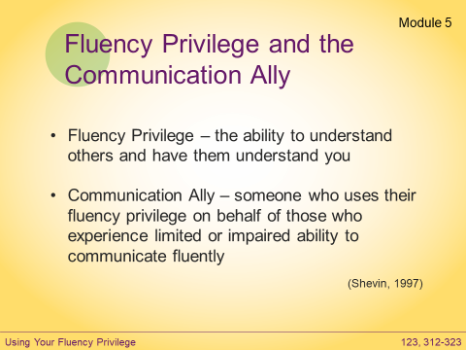  Slide #4 |  | SAY:  In the online module, you were introduced to Fluency Privilege and provided a link to Mayer Shevin’s article: On Being a Communication Ally.  That article has been added to your learning journal (pgs. 8-19). Mayer Shevin (D. 2014) had his Ph.D. in psycholinguistics and was a lifelong advocate for people with disabilities.  Give a green check if you remember something from this article.  DO: Ask for a volunteer or call on one of the participants who gave a green check and ask them to unmute and share what they took away from the article.  Being able to communicate, to understand others and have them understand you is something many of us take for granted.  People who have the ability to effectively communicate their feelings, needs, emotions, and so on, have what Mayer Shevin calls “Fluency Privilege.”  This means that we can enter a situation and expect to be understood and to understand the people around us (for the most part).  People who use their fluency privilege on behalf of those who experience limited or impaired ability to communicate fluently are what Mayer Shevin calls “Communication Allies.”  As a BHP, you have a responsibility to use your fluency privilege to be a communication ally for the child and family that you support.  Being a communication ally is about helping the child get needs and wants met, but also about helping the child express their individuality and be included in society.  Give a green check if you’ve ever traveled to a country and couldn’t speak the language fluently. What was that experience like? Type your thoughts in chat.  Or: Ask for a volunteer or call on one of the participants who gave a green check, asking them to unmute and share what that experience was like.  DO:  Review Shevin’s experiences of his own loss of fluency privilege or share your own.
Slide/Page | Facilitator |  |  | Producer
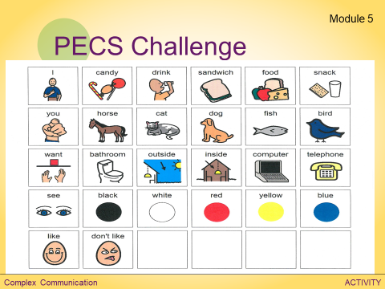  Slide #5 | Instructor’s Note: When building your classroom prior to the training, draw the check mark. Then when the whiteboard tools are enabled, the check mark will become visible/movable. Or enable the whiteboard tools and have the participant use one of the text tool shapes.  SAY:  PECS is a method of communication that teaches the individual to initiate an exchange with a communicative partner. The individual learns to give a picture of a desired item (a ball, for instance) to their communication partner, who then gives the desired item to the individual. Once the individual learns this concept, they are taught how to put vocabulary together to form sentences.  Devices that are used to communicate with PECS range from the traditional communication book (a binder with pictures that stick with Velcro) to PECS software programs, to PECS iPhone apps, and more.  DO:  Using their hand raising tool, ask for a volunteer or one per question.  Direct them to answer the interview questions by dragging the check mark to a PECS symbol (no talking). Facilitator asks the questions:  - Where do you live?  - Tell me about the last movie you saw.  - What is your favorite season? Why?  - What did you have for dinner last night?  - What is your favorite part about this class so far?  DO:  Ask the volunteer(s) to share over audio what this experience was like. Thank them for sharing.  Stress the importance of BHPs helping the child to express preferences and interests. When the child you work with has barriers to communication, whether it is because they are non-verbal, etc., you need to embrace your role as a communication ally.  SAY:  What questions do you have about module 5? Raise your hand or type questions in chat. If you don’t have any questions, give a green  to let me know you’re ready to move on.  DO:  When everyone has given a green check, move to next layout: Module 6 |  |  | DO:  Enable whiteboard tools.  DO:  Disable whiteboard tools.  DO:  Clear green checks and red Xs.

Slide/Page | Facilitator |  | Producer
Layout: Module 6  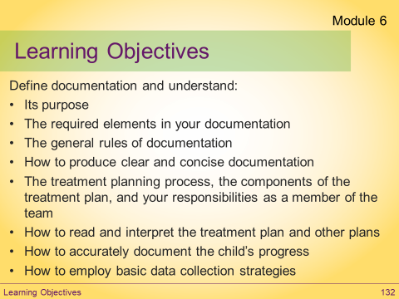  Slide #1  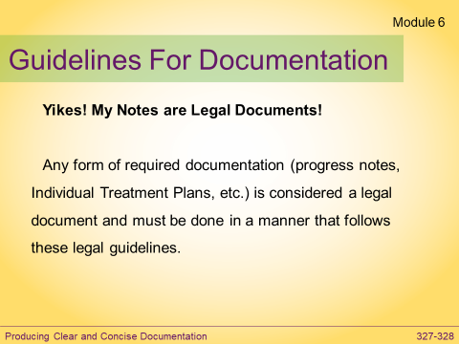  Slide #2 | SAY:  Give me a green check when the Module 6 learning objectives slide has loaded on your screen.  DO:  Wait for everyone to give a green check before moving on.  SAY:  Producing clear, accurate, and objective documentation is a very important part of your job as a BHP.  Module 6 provides you with a wealth of information about the purpose and rules for documentation.  Let’s review some of the important guidelines and talk about objective versus subjective documentation.  SAY:  Why do we document? Type your reasons in chat.  - Track progress  - Proof of service delivery  SAY:  What are some of your organization’s policies for documentation? Type in chat.  DO:  Without re-teaching the material, review the guidelines for documentation (use the Documentation Skills Card in the learning journal on pages 22-23 as a reference).  Remind students that each agency/school and program will have its own specific requirements for writing progress notes, and that it is the BHP’s responsibility to be familiar with their program’s specific rules and requirements for clinical documentation. |  | DO:  Clear green checks.  DO:  Type in chat:  Why document?  DO:  Type in chat:  What are your organization’s policies for documentation?
Slide/Page | Facilitator |  | Producer
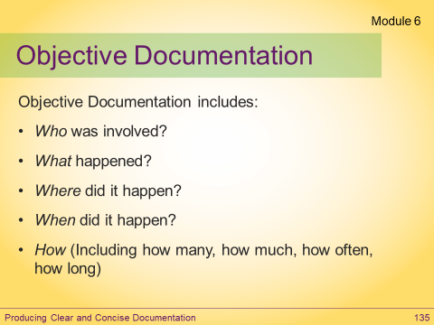  Slide #3  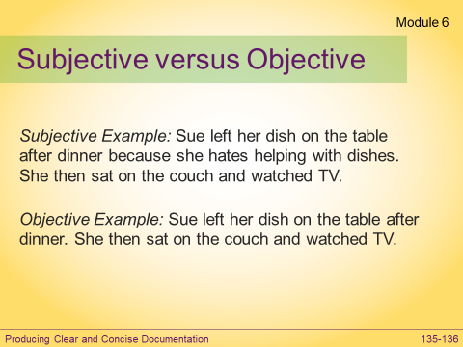  Slide #4 | SAY:  Objective documentation includes the Who, What, Where, When, and How.  This is all information that can be confirmed because it is observable and measureable.  What question is not included in this list? Type your answers in chat.  DO: Wait for participants to respond.  SAY: That’s right – WHY. Why isn’t “why” included in most clinical documentation? Respond in chat.  DO: Wait for participants to respond.  SAY: That’s right. Because “why” is subjective - open to interpretation. Save subjective observations for supervision and strive to remain objective in your written notes.  Your subjective observations are valid. Those of you who work in Section 65 HCT may have a bit more flexibility to include some subjective observation. However, as a rule, subjective observations should be discussed with your supervisor.  SAY:  Examples:  - Subjective Example: Sue left her dish on the table after dinner because she wanted to watch TV.  - Objective Example: Sue left her dish on the table after dinner. She then sat on the couch and watched TV.  One helpful tip for remaining objective would be to imagine taking a mental picture of the situation and recreating that picture in your documentation. Ask yourself, “If someone else was reading this, would they be able to picture the situation based on what I have written? |  | DO:  Type in chat:  What question is not included in this list?  DO:  Type in chat:  Why isn’t “why” included in most clinical documentation?
Slide/Page |  | Facilitator |  | Producer
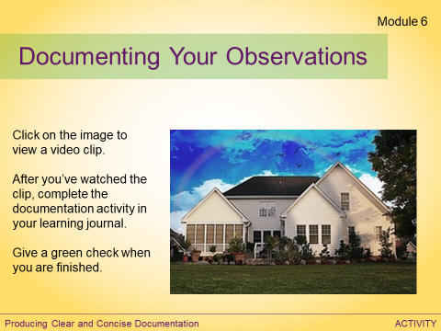  Slide #5  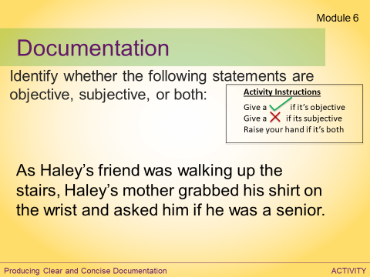  Slide #6 |  | DO:  Have participants click on the link to play the video clip.  Direct them to complete the documentation activity in their learning journal (page 24) after they’ve watched the video and to give a green check when they’re done.  Go through the next slides to process examples as a group.  SAY:  As a class, identify whether the following statements are objective, subjective, or both using feedback tools. Green check for objective, red X for objective, raise hand for both.  DO:  Wait for participants to respond then go over answer.  Instructor’s Note: To solicit more participation from participants, after each example ask learners to share why they thought the sentence was objective/subjective. They can type their rationale in chat or you can call on someone that chose the right answer to explain over audio. |  | DO:  Post link to video in chat:  https://www.youtube.com/watch?v=V_CmBsi17_0  DO:  Clear green checks.  DO:  Clear everyone’s status.
Slide/Page |  | Facilitator |  | Producer
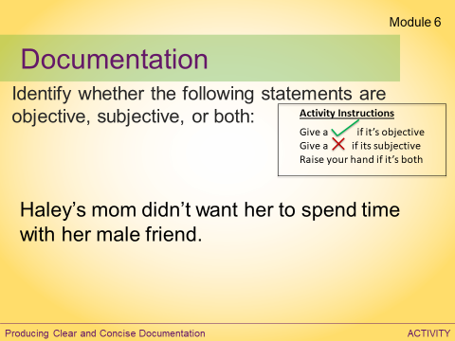  Slide #7  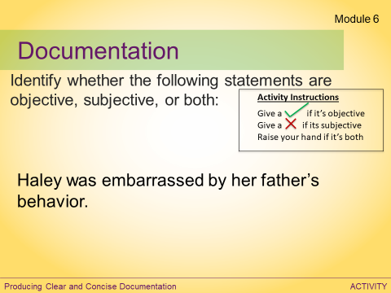  Slide #8 |  | SAY:  As a class, identify whether the following statements are objective, subjective, or both using feedback tools. Green check for objective, red X for objective, raise hand for both.  DO:  Wait for participants to respond then go over answer.  SAY:  As a class, identify whether the following statements are objective, subjective, or both using feedback tools. Green check for objective, red X for objective, raise hand for both.  DO:  Wait for participants to respond then go over answer. |  | DO:  Clear everyone’s status.  DO:  Clear everyone’s status.
Slide/Page |  | Facilitator |  | Producer
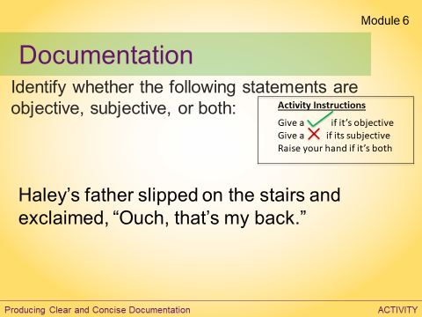  Slide #9  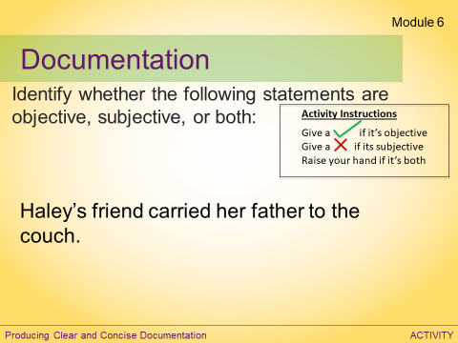  Slide #10 |  | SAY:  As a class, identify whether the following statements are objective, subjective, or both using feedback tools. Green check for objective, red X for objective, raise hand for both.  DO:  Wait for participants to respond then go over answer.  SAY:  As a class, identify whether the following statements are objective, subjective, or both using feedback tools. Green check for objective, red X for objective, raise hand for both.  DO:  Wait for participants to respond then go over answer.  SAY:  What questions do you have about module 6? Raise your hand or type questions in chat. If you don’t have any questions, give a green check to let me know you’re ready to move on.  DO:  When everyone has given a green check, move to next layout: Perspective Video Clip |  | DO:  Clear everyone’s status.  DO:  Clear everyone’s status.  DO:  Clear green checks.

Slide/Page | Facilitator | Producer
Layout: Perspective Video Clip  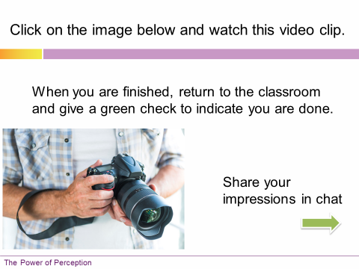  Slide #1 | DO:  Direct participants to click on the image to view the video clip.  Have them give a green check after they’ve watched the clip, and ask them to share their thoughts/reflections about the video in the chat box.  DO:  Review participant responses.  DO:  After participants have responded, move to next layout: Module 7-8. | DO:  Share link to video clip in chat box: https://www.youtube.com/watch?v=F-TyPfYMDK8  DO:  Clear green checks.
Slide/Page | Facilitator | Producer
Layout: Module 7 & 8  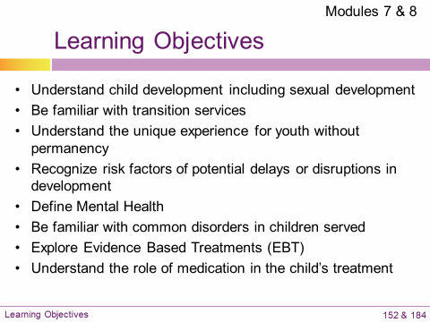  Slide #1 | SAY:  Give me a green check when the Module 7 & 8 learning objectives slide has loaded on your screen.  DO:  Wait for everyone to give a green check before moving on.  SAY:  As a BHP, you provide services to children with a variety of developmental delays and mental health diagnoses.  Module 7 is an introduction and overview of typical child development and the risks and symptoms associated with delays and disruptions in development.  Module 8 is entitled Children's Behavioral Health. This module provides an overview of some of the more common mental health diagnoses you may encounter in your work, and the evidence based treatments recommended for treating those.  I encourage you to review these modules in your student manual. There is a lot of great information and resources to help you in your work.  Today, were are going to focus on the importance of our perspective and being strength-based in our approach to this work. | DO:  Clear green checks.
Slide/Page | Facilitator | Producer
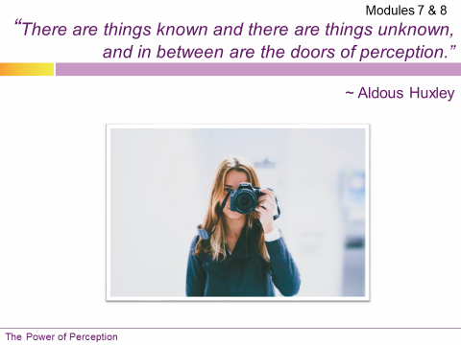  Slide #2 | SAY:  Would you agree that our perception of people has a powerful impact on how we behave toward them as well as how they view themselves? Give me a green check if you agree with that statement.  DO:  Wait for participants to respond.  SAY:  Let’s explore that. | DO:  Clear green checks.
Slide/Page | Facilitator | Producer
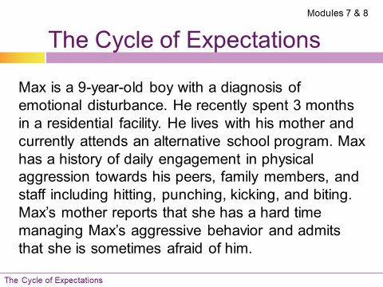  Slide #3 | SAY:  Our beliefs and opinions about the child and family influences how we interact with them.  How they are treated affects their beliefs about themselves, which will influence their behavior, which in turn reinforces our beliefs.  Let’s consider an example:  “In preparation for working with a new child, you read the case record that informs you that:  Max is a 9-year-old boy with a diagnosis of emotional disturbance. He recently spent 3 months in a residential facility. He lives with his mother and currently attends an alternative school program. Max has a history of daily engagement in physical aggression towards his peers, family members, and staff including hitting, punching, kicking, and biting. Max’s mother reports that she has a hard time managing Max’s aggressive behavior and admits that she is sometimes afraid of him.”  SAY:  If this was all the information you had about Max, what might you believe about Max? Type your answers in chat.  DO:  Review participant responses. Possible responses: He’s dangerous. He might get aggressive towards me, I might get hurt, etc. | DO:  Type in chat:  If this was all the information you had about Max, what might you believe about Max?  DO:  Put separating line in chat.
Slide/Page | Facilitator | Producer
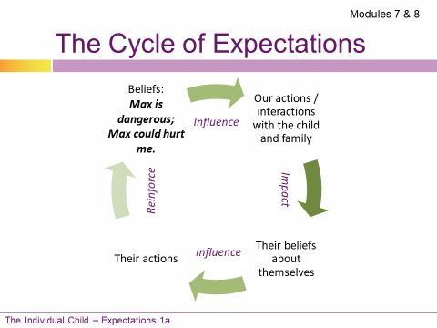  Slide #4  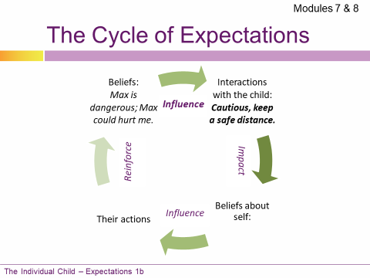  Slide #5 | SAY:  If you believe that Max is dangerous, how might you interact with Max? Type your answers in chat.  DO:  Review participant responses. Possible responses: Cautiously, keep a safe distance, consciously or unconsciously exhibit fear or anxiety, etc.  SAY:  What might Max believe about himself if you, his mother, and other adults and peers behave cautiously around Max or even appear to be afraid of him? Type your answer in chat.  DO:  Review participant responses. Possible responses: I’m bad, I’m dangerous, people don’t like me, etc. | DO:  Type in chat:  If you believe that Max is dangerous, how might you interact with Max?  DO:  Put separating line in chat.  DO:  Type in chat:  If people behave cautiously around Max, what might he believe about himself?  DO:  Put separating line in chat.
Slide/Page | Facilitator | Producer
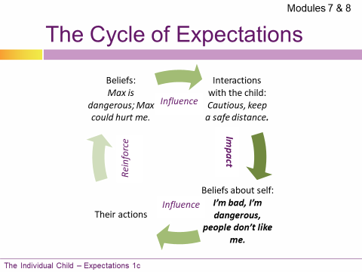  Slide #6  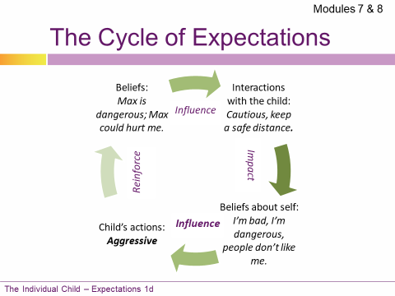  Slide #7 | SAY:  If Max believes that he is bad or that people dislike him or are afraid of him, how might he behave? Type your answer in chat.  DO:  Review participant responses. Possible responses: Maintain or increase aggressive behavior, etc.  SAY:  If Max continues to engage in aggressive behavior, how might that affect your beliefs about Max? Type your answer in chat.  DO:  Review participant responses. Possible responses: It reinforces those beliefs. | DO:  Type in chat:  If Max believes he is bad, how might he behave?  DO:  Put separating line in chat.  DO:  Type in chat:  If Max continues to engage in aggressive behavior, how might that affect your beliefs about Max?  DO:  Put separating line in chat.
Slide/Page | Facilitator | Producer
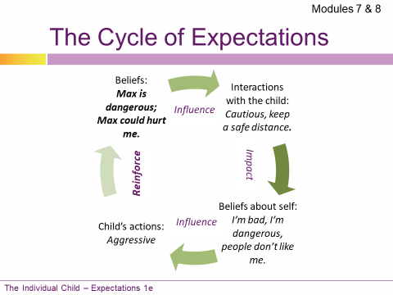  Slide #8  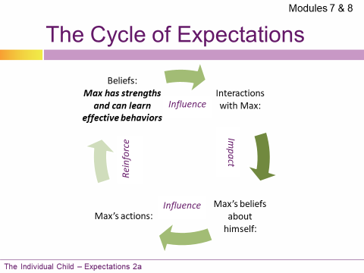  Slide #9  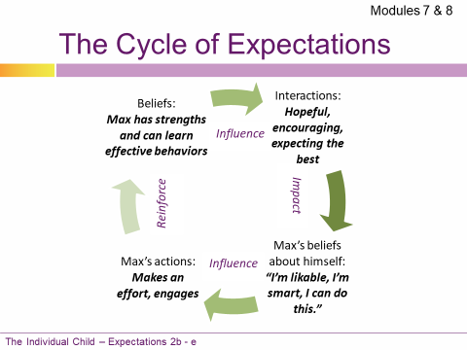  Slide #10 | SAY:  And the cycle of expectations continues around and around.  SAY:  But what if, despite knowing Max’s history of aggression, you choose to believe that you and the treatment team will come to understand the function of Max’s aggressive behavior and will be able to effectively manage his behavior and de-escalate him? You decide to withhold judgment about Max and believe the best.  How does the cycle of expectations change? Type your answer in chat.  DO:  Review the changes in the cycle when our expectations are strength-based.  Emphasize the importance of identifying and building on the child and family’s strengths. | DO:  Type in chat:  If you decide to believe the best about Max, how does the cycle of expectations change?
Slide/Page | Facilitator | Producer
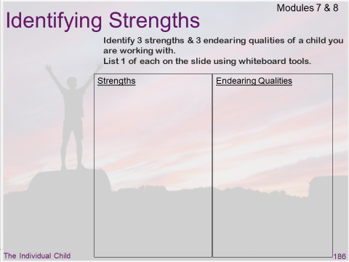  Slide #11 | SAY:  So we can see how important it is that we look past the challenging behavior and identify strengths for each child that we are working with.  DO:  Direct participants to page 186 of their student manual. In the space provided, ask them to write down three strengths and three things that they like about the child they are working with.  Ask each person to share one strength and one thing they like about the child with the class on the slide using whiteboard tools.  Thank participants for sharing. | DO:  Enable whiteboard tools.  DO:  Disable whiteboard tools.
Slide/Page | Facilitator | Producer
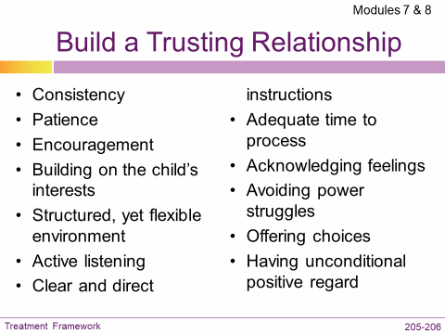  Slide #12  Slide is animated | SAY:  There are some core principles that are crucial to your effectiveness as a BHP.  Regardless of the child’s diagnosis, building trust with the child with whom you work is key.  What are the things that you do to build trust? Type your answers in chat.  DO: Review participant responses then advance animation.  Go over any bullet points not mentioned by participants using information below:  - Be consistent in your expectations, maintaining boundaries, as well as being consistent in your mood, reactions, and responses.  - Be calm, patient, and hopeful regardless of how the child is behaving.  - Give frequent positive feedback.  - Start with where the child is at and build on their interests.  - Whenever possible, be organized and create an environment that is predictable, yet flexible.  - Employ active listening as we discussed in the communication module.  - When giving directions or instruction, make sure that you are specific, clear, and communicating in a way that the child understands.  - Give the child the time they need to process what you say (15 to 30 seconds is a good starting point).  - Acknowledge and validate the child’s feelings without reinforcing challenging behavior.  - Avoid power struggles.  - Offer choices.  - Maintain unconditional positive regard for the child and family.  SAY:  What questions do you have about modules 7 & 8? Raise your hand or type questions in chat. If you don’t have any questions, give a green check to let me know you’re ready to move on.  DO:  When everyone has given a green check, move to next layout: Module 9. | DO:  Type in chat:  What are the things that you do to build trust?  DO:  Put separating line in chat.  DO:  Clear green checks.

Slide/Page | Facilitator | Producer
Layout: Module 9  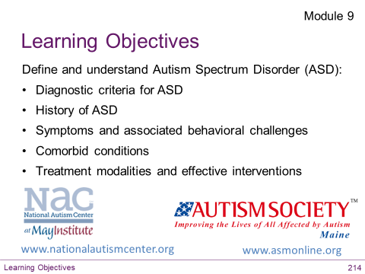  Slide #1 | SAY:  Give me a green check when the Module 9 learning objectives slide has loaded on your screen.  DO:  Wait for everyone to give a green check before moving on.  SAY:  How many of you are working or have worked in the past with children who have a diagnosis of Autism Spectrum Disorder (ASD)?  Give me a green check  As we learned, the incidence of children being diagnosed with ASD has increased steadily over the past few decades and according to the CDC is currently 1 in 59* children in the US. (*2018 CDC report)  Due to the pervasiveness of ASD, it is important that you have a general understanding of this disorder.  While more is known about ASD than in years past, there are still many things about ASD that remain unexplained and research is ongoing.  Use your student manual as a refresher to the online module and stay informed about current research and best practices.  Make sure that the information you acquire is coming from a reputable source.  Some reliable sources include:  - National Autism Center at the May Institute  - Autism Society  - The Autistic Self Advocacy Network is involved in public policy advocacy.  - The CDC also provides a list of links to organizations such as Autism NOW, Autism Speaks and more https://www.cdc.gov/ncbddd/autism/links.html | DO:  Clear green checks.  DO:  Clear green checks.  DO:  Copy and paste the link to the CDC website in chat.
Slide/Page | Facilitator | Producer
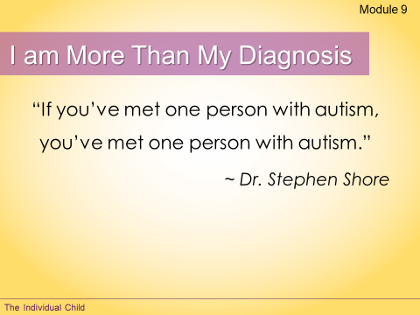  Slide #2 | SAY:  As with every diagnosis, symptoms manifest differently depending on the individual.  Individuals are often faced with being defined by that diagnosis. Assumptions about what individuals are like, and what their capabilities are, can obscure their other attributes.  Part of our responsibility as advocates for the individuals we serve is to help broaden the ideas that other people have regarding developmental disabilities and behavioral/mental health.  Just as we want to make sure that others have an accurate perception of us based on our numerous attributes, it is important that professionals look past the diagnosis (ASD or others) and develop an independent and accurate perception of each individual we serve.  As we have just discussed, you have the power to influence how a person is seen, as well as how they see themselves.  When the perception is positive, individuals are empowered.  What questions do you have about module 9? Raise your hand or type questions in chat. If you don’t have any questions, give a green check to let me know you’re ready to move on.  DO:  When everyone has given a green check, move to next layout: Module 10. | DO:  Clear green checks.

Slide/Page | Facilitator | Producer
Layout: Module 10  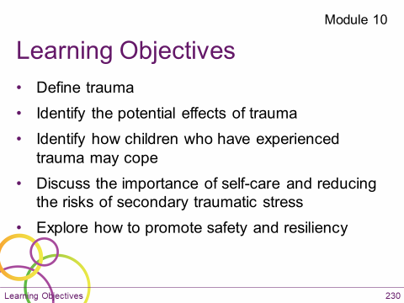  Slide #1 | SAY:  Give me a green check when the Module 10 learning objectives slide has loaded on your screen.  DO:  Wait for everyone to give a green check before moving on.  SAY:  Due to the pervasiveness of traumatic experiences among children receiving mental health services, there has been an increased emphasis on behavioral health services providing “Trauma-informed care”.  This means that you and other providers understand, recognize, and respond to the effects of trauma in the populations we serve.  Module 10 is devoted to helping you understand the fundamentals of trauma so that you can respond appropriately.  I encourage you to read this module in your student manuals. | DO:  Clear green checks.
Slide/Page | Facilitator | Producer
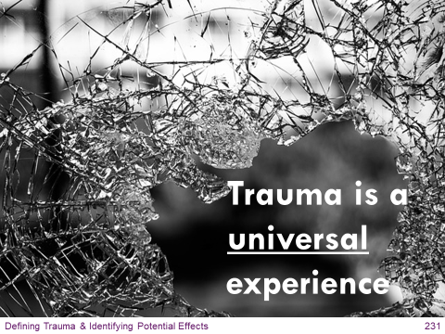  Slide #2 | SAY:  All of us have had an event or events in our lives that took us by surprise and left us feeling overwhelmed due to a lack of safety and/or control.  Each of us, during and following a traumatic experience, gather our unique set of resources and find ways to cope and make sense of what happened.  We then do our best to understand and integrate the experience into our lives, and it shapes who we are.  What happens to the brain as a result of trauma? Type your answers in chat.  DO:  Go over participant responses, then go over information below:  - Maltreatment/trauma takes away the child’s sense of safety and continues to affect the child’s perception of reality.  - The brain gets wired to expect danger.  - The child becomes hypervigilant and their brain has difficulty distinguishing between stimuli.  - For example, imagine children are walking through the halls at school between classes and two students bump into each other. The child who has a reasonable sense of safety will likely brush it off, keep going, and may even say, “Excuse me.” But a child who has a trauma history may interpret that interaction as a threat to their safety and may respond by becoming aggressive, threatening the other student, or may run away crying.  - These are safety-seeking behaviors in the face of what the child perceives to be a threat.  - Unfortunately, safety-seeking behaviors are often problematic, and may get the child “in trouble” with their peers and adults.  - As they grow, children need help to develop healthier, more appropriate ways of coping. And that is where you and the treatment team come in.  SAY:  Part of your job as a BHP is to promote and maintain safety for the children and families we serve and to build resilience.  Today we are going to focus on resilience. | DO:  Type in chat:  What happens to the brain as a result of trauma?  DO:  Put separating line in chat.
Slide/Page | Facilitator | Producer
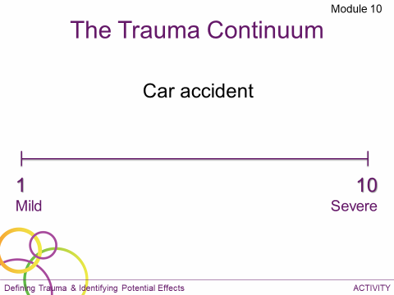  Slide #3  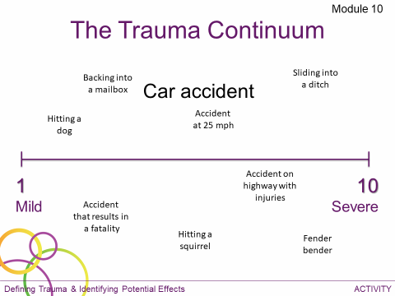 | DO:  Instruct participants to use the selection tool to drag the accident to where it would fall on the continuum. Instructor can choose to have participants do this all at once or one at a time.  After participants complete activity, talk about the subjective nature of traumatic experiences and some of the variables that could make an experience feel more or less traumatic. (For example, backing into a lamppost and incurring minimal auto damage might be a 1, while backing into an occupied car might be a 4 or 5 and backing into a person might be a 10.)  SAY:  Reactions to trauma might include unwanted or upsetting memories or dreams of the events, jumpiness, irritability, difficulty concentrating, trouble sleeping, avoiding similar situations, feeling sad or anxious, etc. If we, as adults, react or respond in these ways, imagine how these responses may be intensified for children who feel less control over their circumstances and their lives. | DO:  Enable whiteboard tools. You will need to pre-load the different examples of accidents for participants to be able to drag and drop on the whiteboard.  DO:  Disable whiteboard tools.
Slide/Page | Facilitator | Producer
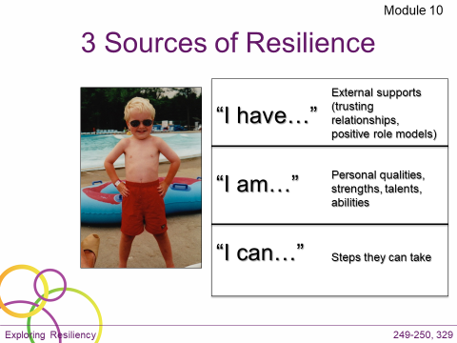  Slide #4  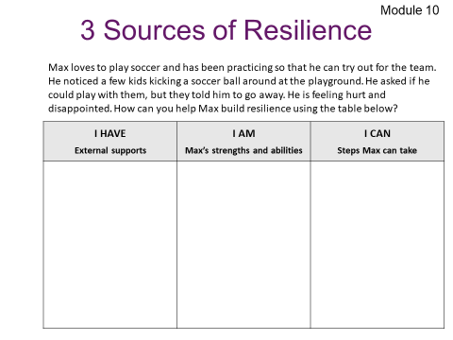  Slide #5 | SAY:  In her booklet A Guide to Promoting Resilience in Children: Strengthening the Human Spirit, Dr. Edith Grotberg identifies three sources of resilience that children can draw from.  - I HAVE… identifies external supports that promote feelings of safety, security, and stability, i.e., trusting relationships, positive role models. Kids with a strong relationship with at least one competent, caring adult are more likely to be resilient.  - I AM… identifies personal qualities/strengths/talents/abilities, etc. I AM “LOVEABLE”, “CAPABLE”, “CARING”, “INTELLIGENT”.  - I CAN… identifies steps they can take. i.e., talk to someone, solve problems, manage feelings, and understand others.  You have this activity on page 25 in your learning journal to help a child you are working with. For now, we will practice going through this together with an example scenario.  DO:  Instruct participants to use whiteboard tools to complete this chart for the scenario.  Depending on the size of the class, you may want to divide participants into separate groups to keep the slide from getting too cluttered and to make sure each section is addressed.  Review their responses. | DO:  Enable whiteboard tools.  DO:  Disable whiteboard tools.
Slide/Page | Facilitator | Producer
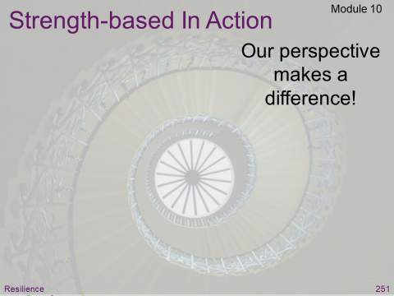  Slide #6 | SAY:  You were sent a link to a Ted Talk by Shawn Achor. What did you take away from that? Type your impressions on the slide using whiteboard tools.  DO:  Review responses, and add relevant information using talking points listed below:  Stress/challenges are unavoidable.  It is our perspective that makes the difference.  His research shows that only 25% of job success is predicted by IQ; 75% of success is predicted by:  - Optimism level  - Social support  - Ability to view stress/obstacles as a challenge versus threat  The reason for this is that our brains perform better when they are positive versus when they are negative, neutral, or stressed.  Being positive increases creativity, energy levels, and intelligence, making individuals more productive.  Why? Because, when we see challenges as temporary and local - as an opportunity, dopamine is activated. Dopamine makes us happier and turns on all the learning centers in the brain, allowing us to work harder, faster, and more intelligently. As opposed to when we see challenges as permanent and pervasive, which activates cortisol and the fight or flight response. | DO:  Enable whiteboard tools.  DO:  Disable whiteboard tools.
Slide/Page | Facilitator | Producer
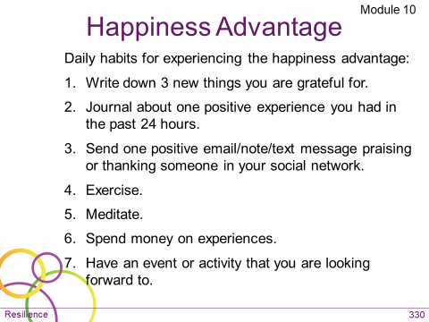  Slide #7 | DO:  Encourage participants to incorporate Shawn’s happiness advantage habits and “I have, I am, I can” into their daily self-care routine.  This outline is provided on page 26 in the learning journal: Happiness Advantage Daily Habits (#6 & #7 are not mentioned in the TED Talk but are from Shawn’s book, The Happiness Advantage).  SAY:  Because of neuroplasticity, making these types of choices and changes in our day-to-day behavior creates an advantageous change in the brain and builds resilience.  What questions do you have about module 10? Raise your hand or type questions in chat. If you don’t have any questions, give a green check to let me know you’re ready to move on.  DO:  When everyone has given a green check, move to next layout: Module 11. | DO:  Clear green checks.

Slide/Page |  | Facilitator | Producer
Layout: Module 11  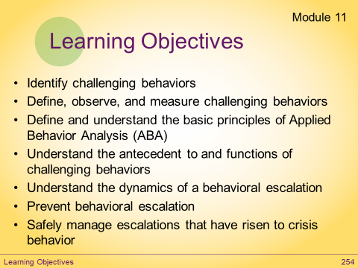  Slide #1 |  | SAY:  Give me a green check when the Module 11 learning objectives slide has loaded on your screen.  DO:  Wait for everyone to give a green check before moving on.  SAY:  In module 11, we discuss the principles of behavior.  This includes an overview of Applied Behavior Analysis (ABA), which is an evidenced-based treatment for individuals with Autism. ABA examines the influence of the environment on behavior and applies interventions to improve socially significant behaviors.  Today, we will review some of the essentials for managing challenging behavior, as well as managing our own behavior in response to challenging behavior. | DO:  Clear green checks.
Slide/Page |  | Facilitator | Producer
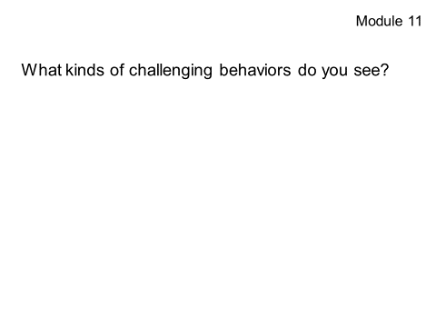  Slide #2 |  | SAY:  How many of you work with children who exhibit problematic or challenging behaviors? Give a green check if you do.  DO:  Wait for participants to respond.  SAY:  For those of you that gave green checks, what kinds of challenging behaviors do you see? Type your answers on the slide using whiteboard tools.  DO:  Wait for participants to respond.  SAY:  What makes these behaviors problematic or challenging? Type your answers in chat.  DO:  Allow participants to respond, then go over any information they missed using talking points below:  Challenging behaviors are challenging because of the following:  - Harmful to self or others  - Disruptive to the routines of self or others  - Causes serious or repeated property destruction  - Keeps the person from achieving personal goals  - Causes the person to be restricted from accessing their peers or community | DO:  Enable whiteboard tools.  DO:  Clear green checks.  DO:  Type in chat:  What makes these behaviors problematic or challenging?  DO:  Disable whiteboard tools.
Slide/Page | Facilitator |  |  | Producer
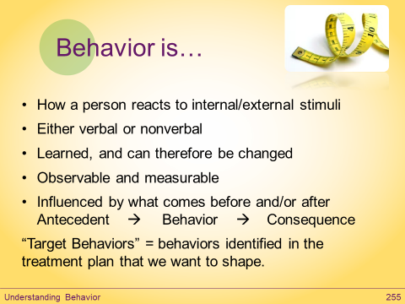  Slide #3  Slide is animated  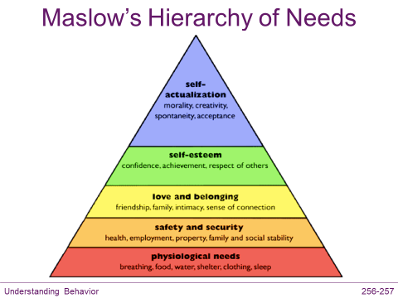  Slide #4 | SAY:  Some behaviorists say that “behavior is anything that a dead man can’t do.”  “Target Behaviors” are the behaviors identified in the treatment plan that we want to shape; either to increase desirable behaviors or decrease challenging behaviors  SAY:  Who is familiar with Maslow and is willing to provide a brief explanation of his Hierarchy of Needs? Raise your hand and unmute to share your insights.  SAY:  Thank you! Yes, Maslow suggests that, as humans our behavior is motivated by our needs, which he organized in this hierarchy beginning with our most basic needs for food, shelter, etc. and then our need for safety, need for love and belonging and so on. Our most basic needs must first be met before we can attend to our higher needs.  How does this help us as BHPs? Type your answers in chat.  When you see challenging behavior, one of the first question you should ask is, “What need might the child be trying to meet with this behavior?” For example, is the child hungry, tired, cold, sick, or in pain? Or as we just learned in module 10, using our trauma-informed lens, could the child be feeling unsafe due to a perceived threat.  Making sure basic needs are met is an important part of managing challenging behavior. A child whose nutritional needs are met, or who feels safe is going to be better able to attend and learn. |  |  | DO:  Type in chat:  How does understanding Maslow’s Hierarchy help us as BHPs?
Slide/Page |  | Facilitator | Producer
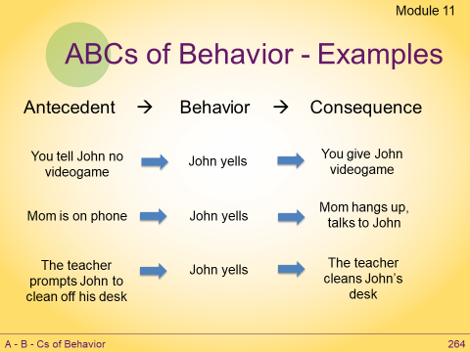  Slide #5  Slide is animated |  | SAY:  Behaviorism seeks to understand behavior in terms of the ABCs of behavior:  - Antecedent: Stimuli or events that occur before the behavior.  Antecedents may or may not influence a behavior.  - Behavior: Something someone does that is both measurable and observable.  Behavior can be influenced by consequences and relevant antecedents.  - Consequence: Something that happens after the behavior.  Consequences may be experienced as either reinforcement or punishment.  Reinforcement increases the likelihood of the behavior occurring again and punishment decreases the likelihood.  DO:  Go through examples on the slide.
Slide/Page |  | Facilitator | Producer
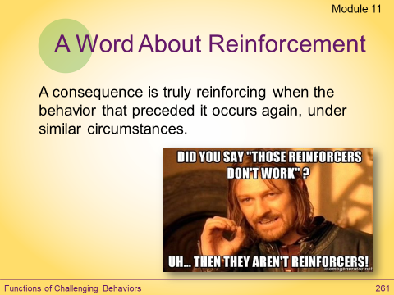  Slide #6 |  | SAY:  When a behavior occurs and a desirable consequence follows, the behavior is being reinforced – meaning that same behavior is more likely again.  Through reinforcement you can increase the likelihood of a desirable or challenging behavior occurring in the future. In the examples we just reviewed, the desirable consequences that followed John yelling, are reinforcing his challenging behavior.  Not every consequence that follows a behavior is reinforcing. Reinforcement only occurs if the behavior occurs again under similar circumstance.
Slide/Page |  | Facilitator | Producer
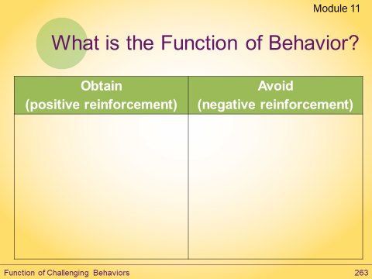  Slide #7 |  | SAY:  What is the function of behavior? Why do people do things?  According to behaviorism, there are two functions of behavior:  - to obtain or  - avoid something.  What might the child be trying to obtain? What might they be trying to avoid? Type your answers in the table using whiteboard tools.  DO:  Allow participants to respond, then go over any missed answers using information below:  - The child might try to obtain:  - Attention/Interaction  - Task/Directive/Activity  - Tangible item  - Internal stimulation  - The child might try to avoid:  - Attention/Interaction  - Task/Directive/Activity  - Internal Stimulation | DO:  Enable whiteboard tools.  DO:  Keep whiteboard tools enabled for next activity.
Slide/Page |  | Facilitator | Producer
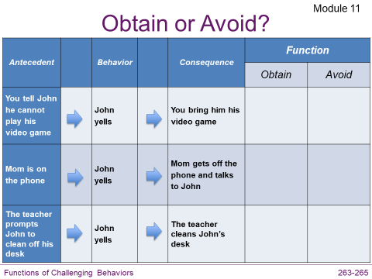  Slide #8  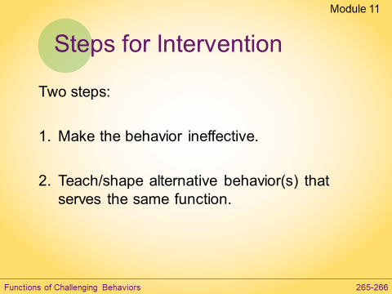  Slide #9 |  | DO:  Ask participants what the function of behavior is for each of the previous examples under the ABC model. For each example, direct them to put a checkmark in the column to note whether the function is obtain or avoid.  After participants have responded, go over answers below:  - Obtain (video game)  - Obtain (mom’s attention)  - Avoid (cleaning task)  SAY:  The same behavior serves different functions.  SAY:  In order to change behavior, there are two key steps for intervening.  - Make the target or challenging behavior ineffective.  AND  - Teach and shape an alternative behavior that serves the same function.  We can apply these steps to change John’s yelling behavior.  In each of the examples, John is getting a desired consequence or result from his behavior.  - We can change the yelling behavior by making the behavior ineffective. We do this by no longer providing the reinforcing consequence.  - And we teach an alternative behavior that will serve the same function. | DO:  Make sure whiteboard tools are enabled.  DO:  Disable whiteboard tools.
Slide/Page |  | Facilitator | Producer
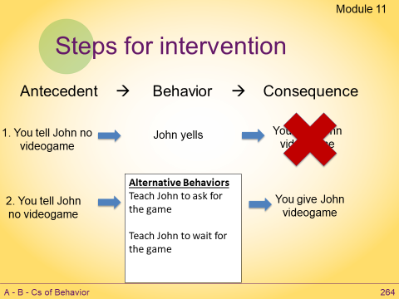  Slide #10  Slide is animated |  | SAY:  Let’s imagine that we are Behavior Analysts and we’ve collected some data to help us determine the function of John’s behavior. Together let’s brainstorm some possible intervention for making John’s behavior of yelling ineffective and teaching an alternative behavior that serves the same function.  For the first example, we make the behavior ineffective by not giving John his game when he yells.  DO:  Advance animation.  SAY:  We also need to teach John some alternative behaviors so that he can get the video game.  DO:  Advance animation to show alternative behaviors.
Slide/Page |  | Facilitator | Producer
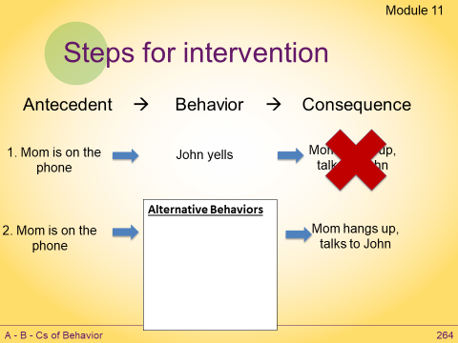  Slide #11  Slide is animated |  | SAY:  For the second example, we make the behavior ineffective by not providing attention when John yells.  DO:  Advance animation.  SAY:  We also need to teach John some alternative behaviors so that he can get mom’s attention.  DO:  Advance animation to show box for alternative behaviors. Direct participants to use whiteboard tools to type some alternative behaviors John could learn to get mom’s attention.  Review participant responses.  Possible answers: Saying “excuse me” or tapping mom on the arm.  SAY:  Reinforce John’s behavior by providing attention immediately after he uses one of these alternative behaviors. | DO:  Enable whiteboard tools.  DO:  Keep whiteboard tools enabled for next slide.
Slide/Page |  | Facilitator | Producer
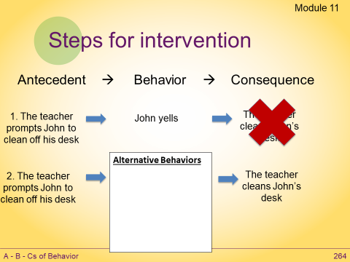  Slide #12  Slide is animated  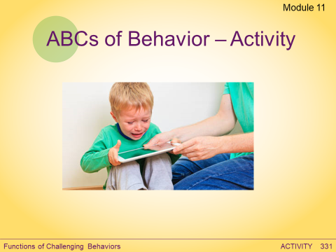  Slide #13 |  | SAY:  For the third example, we make the behavior ineffective by not allowing John to escape the task when he yells.  DO:  Advance animation.  SAY:  We also need to teach John some alternative behaviors to escape the task.  DO:  Advance animation to show box for alternative behaviors. Direct participants to use whiteboard tools to type some alternative behaviors John could learn to escape the task. Review participant responses.  Possible answers: Saying “no thank you” or in a “minute”  SAY:  Reinforce John’s behavior by allowing him to escape or delay the task after he uses one of these alternative behaviors.  DO:  Explain ABC activity (pg. 27 in learning journal). Let participants know it is not intended to be used for the purpose of treatment planning, but that it may be a helpful resource for them to use to look for and identify patterns of behavior. | DO:  Make sure whiteboard tools are enabled.  DO:  Disable whiteboard tools.
Slide/Page |  | Facilitator | Producer
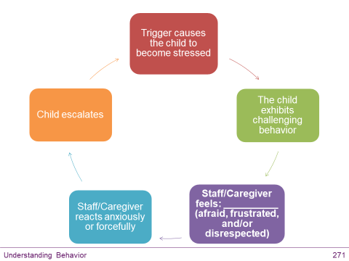  Slide #14 |  | SAY:  It is important to be aware of how you are feeling and reacting to challenging behavior.  When a child is exhibiting challenging behavior or experiencing a behavioral crisis, it is natural for the people around them to become stressed.  You might feel scared, angry, or frustrated.  While it is natural to experience these feelings, it is not helpful to act on them.  If you react to the child’s behavior with fear, anger, or frustration, you will likely only make the situation worse.  It is important to remember not to take the child’s behavior personally.  Develop strategies to help you manage your reactions so that you can move away from instinctual ways of reacting to intentional ways of responding.  What questions do you have about module 11? Raise your hand or type questions in chat. If you don’t have any questions, give a green check to let me know you’re ready to move on.  DO:  When everyone has given a green check, move to next layout: Module 12. | DO:  Clear green checks.

Slide/Page |  | Facilitator |  | Producer
Layout: Module 12  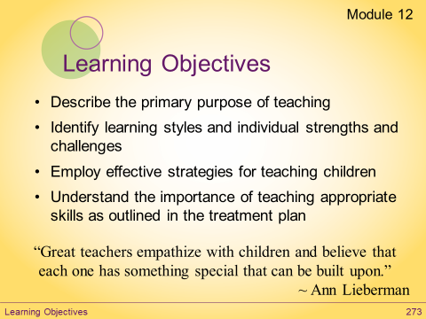  Slide #1 |  | SAY:  Give me a green check when the Module 12 learning objectives slide has loaded on your screen.  DO:  Wait for everyone to give a green check before moving on.  SAY:  Whether you work in a school setting or in the child’s home and community, you are a teacher to the child/children you work with.  Module 12, Principles of Instruction, looks at a variety of teaching methods.  Through these methods, as outlined in the child’s ITP (and where applicable the IEP), the goal is to increase the function and understanding of that child. |  | DO:  Clear green checks.
Slide/Page |  | Facilitator |  | Producer
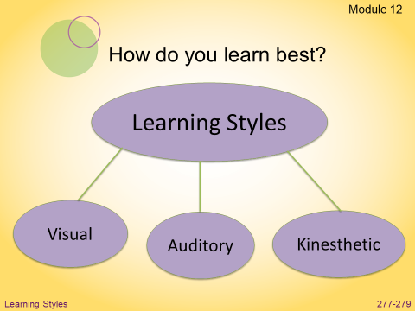  Slide #2 |  | SAY:  How do you learn best? Respond to the poll question.  DO:  Allow time for participants to respond to the poll.  SAY:  It’s important to keep in mind that just like we all have our preferred learning styles, the children we support all have their preferred learning styles, too, and those might differ from yours.  While you might be an auditory learner, you might work with a child who is a visual learner, and would need you to show them how to do something in order for them to be successful.
Slide/Page |  |  | Facilitator |  | Producer
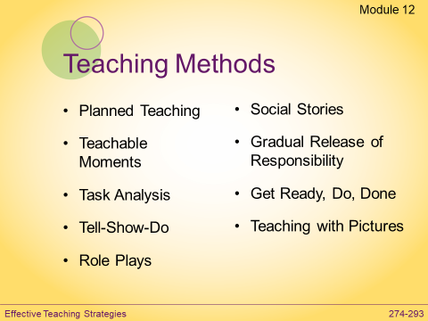  Slide #3 |  |  | DO:  Direct participants to review teaching methods listed on the slide and using the white board tools, have them put a checkmark or star next the ones they have found to be most effective with the children they work with. Describe any methods participants may be unfamiliar with.  - Planned Teaching: Requires you to plan or prepare in advance to work on goals  - Teachable Moments: Sometimes referred to as “happy accidents;” taking advantage of teaching opportunities that you did not plan for  - Task Analysis: Teaching a skill by breaking it down into small, manageable steps  - Tell – Show – Do – Apply: First, you tell the child the specific steps of the skill, then you show the child what it looks like to engage in the skill, then you have the child do it, then you give the child the opportunities to apply the skill in real-world situations  - Role Plays: Allowing a child to safely try a new skill while keeping the risks of failure low  - Social Stories: A social learning tool tailored to the specific child, that accurately describes a context, skill, achievement, or concept according to 10 defining criteria. While anyone can learn to write social stories meeting the 10 criteria, you should consult with the treatment team and/or clinician, BCBA, or field supervisor before implementing this strategy.  - Gradual Release of Responsibility Model: A model which follows four stages of developing self-regulation (1. BHP does it, child watches; 2. BHP does it, child helps; 3. Do it together, BHP helps; 4. Child does it, BHP watches).  - Get Ready, Do, Done Model: The chart helps guide the child in preparing to complete a task, beginning with the “Done” column (the desired outcome), and building onto the process.  - Teaching with Pictures: Using pictures to prompt children to complete activities (Example: Showing a picture of a little girl all ready for school, and asking the child to match the picture. If permitted, it may be beneficial to use a picture of the child you are working with.) |  | DO:  Make sure whiteboard tools are enabled.  DO:  Disable the whiteboard tools.
Slide/Page |  | Facilitator |  | Producer
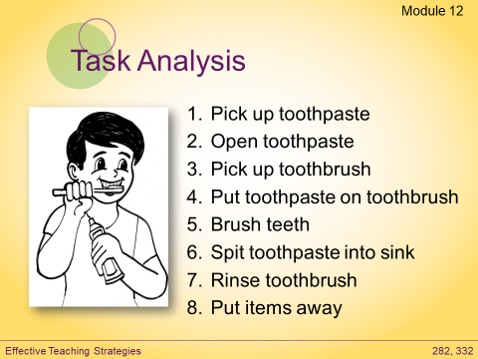  Slide #4 |  | DO:  Review the task analysis example on the slide, then move into the activity.
Slide/Page | Facilitator |  |  |  |  | Producer
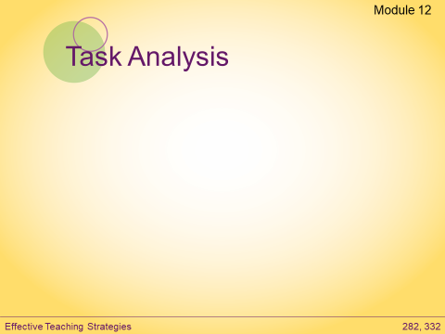  Slide #5 | DO:  Instruct participants to write a fairly simple task analysis teaching the instructor how to draw a picture of a house using whiteboard tools. Direct them to page 28 in the learning journal.  Allow participants a few minutes, then ask for a volunteer (using hand raising tool).  Call on volunteer, ask them to unmute themselves and slowly read their task analysis over audio while the instructor follows the directions exactly as written.  Thank the volunteer, then go over talking points below:  - When we teach skills, we have to take into account the learner, how they learn, how many steps they need, etc.  - It’s also very important that providers and caregivers are on the same page when teaching the same person.  - If more than one person is working on a skill with a child, they all need to be consistent, and break it down the same way.  - After writing a task analysis, the best thing to do is have someone else test it.  - The purpose of this activity is to illustrate the importance of testing a task analysis once it’s been written. Does it make sense? Does it work? Is it broken down into enough steps?  - When writing a task analysis, the number of steps to complete the task will be dependent on the learner.  - A task analysis can be taught in a couple ways. The way the task will be taught will be outlined in the child’s plan and will depend on the learner and the task itself.  - The forward chaining technique moves a child from the first part of the task to the end. In short, each step must be mastered before the next step in the skill series is added.  - The backward chaining technique involves the same process as forward chaining, except in reverse. That is, the teaching process moves from the last part of the task to the beginning. This technique is used when it is easier to teach a child a task from the last step than from the beginning. |  |  |  |  | DO:  Enable whiteboard tools.
Slide/Page |  | Facilitator |  | Producer
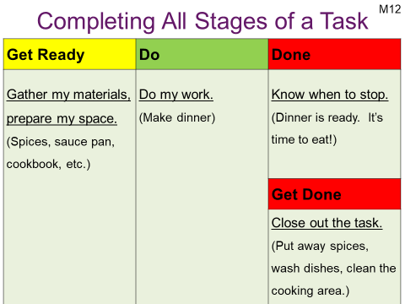  Slide #6 |  | SAY:  The Get Ready, Do, Done Model can assist children who have difficulty completing all stages of a task. The task map, or chart, helps guide the child in preparing to complete a task.  Planning will begin with the “Done” column, because, in order to properly plan, the child needs to identify the desired outcome first. Once that has been established, the child will be able to build onto the process.  After a task is complete, it’s important to help the child learn how to “Get Done.” That means closing out the tasks; putting away materials, cleaning up, etc.
Slide/Page |  | Facilitator |  | Producer
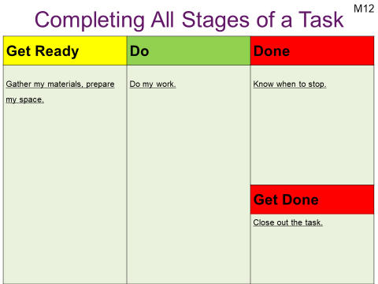  Slide #7 |  | DO:  Using the Get Ready, Do, Done task map on page 29 in the learning journal, instruct participants to create their own Get Ready, Do, DONE task map for: Getting dressed. (For staff working in the home setting this could be getting dressed for school. For staff working in the school setting this could be getting dressed to go outside on a cold, winter day.)  Remind the participants to start in the “Done” section and then go back to “Get Ready.”  Complete chart as a group using whiteboard tools. Call on volunteers or assign people to work on each section.  Review participant responses.  What questions do you have about module 12? Raise your hand or type questions in chat. If you don’t have any questions, give a green check to let me know you’re ready to move on.  DO:  When everyone has given a green check, move to next layout: Revisit Take Aways. |  | DO:  Enable whiteboard tools.  DO:  Disable whiteboard tools.  DO:  Clear green checks.

Slide/Page | Facilitator | Producer
Layout: Revisit Take Aways  Slide #1 | DO:  Have participants review their take-aways from the beginning of class, and direct them to put a green check mark next to their take away if they feel it was met.  Let participants know that if they have additional questions, they can raise their hand, or type them into the public or private chat.  Ask participants to give a green check when they are done reviewing their take-aways and are ready to move on to the closing activity.  When everyone has given a green check, move to next layout: Closing | DO:  Enable whiteboard tools so that take aways from beginning of class appear.  DO:  Keep whiteboard tools enabled for next activity.  DO:  Clear green checks.

Slide/Page | Facilitator | Producer
Layout: Closing  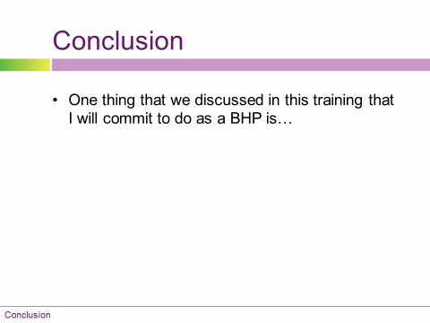  Slide #1 | DO:  Ask participants to use whiteboard tools to write one thing that they are committing to incorporating into their work.  Have participants give a green check when they are done.  Wait for everyone to give a green check before moving on. | DO:  Make sure whiteboard tools are enabled.  DO:  Clear green checks and disable whiteboard tools.
Slide/Page | Facilitator | Producer
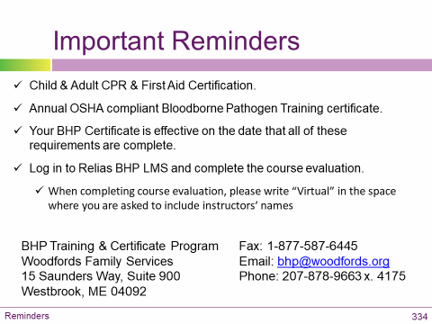  Slide #2 | SAY:  Finally, on page 30 of the student manual there is reminder about the requirements for BHP certification and contact information for the BHP Training & Certificate Program.  If you haven’t already done so, please submit the following:  - Proof of current Child & Adult CPR & First Aid Certification  - Proof of Annual OSHA compliant Bloodborne Pathogen training certificate (if it has been more than 365 days since completion of BBP training then it must be taken again)  Your BHP Certificate is effective on the date that all of these requirements are complete.  I will be submitting the roster from today’s class to Woodfords. Once you are marked complete (in the next day or so) the course evaluation will be available to you online.  Log in to Relias BHP LMS and complete the BHP course evaluation. When completing the evaluation, please enter my name and add the word “virtual” in the space where you are asked to include instructor’s names.  Your BHP certificate will not be issued until you have completed the evaluation.  I’ll stay on and answer any questions you may have. If you don’t have any questions, you are free to exit the virtual classroom. Thank you for your participation and have a great day!

